https://www.thetimes.com/uk/healthcare/article/ambulance-trust-covered-up-paramedics-fatal-errors-like-a-criminal-gang-f9ncnbjcs?gaa_at=eafs&gaa_n=AWEtsqdKQI4vd3WQqmNaag66BrNPrNYLzTNLLuauolFUc3sBNQexu-OFIWTJU4c0RxA%3D&gaa_ts=69c9af90&gaa_sig=1rUs6qujDFA436PeAWokJu8ntvmrHItU9tnSC2OKt_ZQ5BzwbOVc7skC2sMW7Tn1lvSj6mhgPpO1yfEG71J-hg%3D%3D

Ambulance trust covered up paramedics’ fatal errors like a ‘criminal gang’
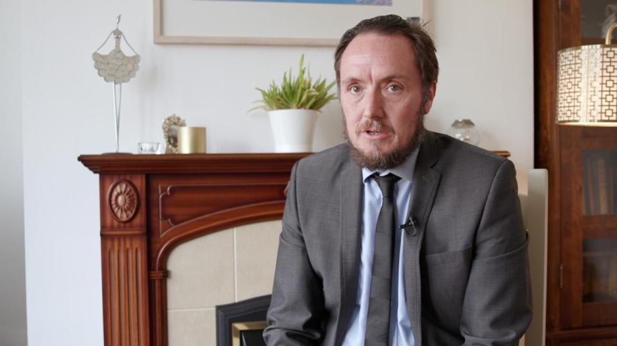
Play Video
David Collins and and Hannah Al-Othman
Sunday May 29 2022, 12.01am, The Sunday Times
Share
Save
An ambulance trust has been accused of acting like a “criminal gang” and lying to dead patients’ families by an employee who repeatedly warned about paramedics’ mistakes being covered up.
Paul Calvert, a coroner’s officer whose job was to produce reports on deaths, tried to raise concerns about managers at the North East Ambulance Service (NEAS) for three years before walking out last year on the verge of a breakdown.
“My life was being made a misery,” said Calvert, who was previously a detective with Northumbria police. “They were basically like a criminal gang. I had tried everything I could to warn the proper authorities about how the service was destroying and concealing evidence meant for the coroner. I spoke to my managers, to human resources, to external auditors. I even made disclosures to the Care Quality Commission and Northumbria police. Nothing was done about it.”
Despite their denials of a large-scale cover-up of mistakes, the NEAS this year offered Calvert £41,000 as part of a non-disclosure agreement it asked him to sign. One of the clauses meant destroying all the evidence he had collected. Another tried to stop him making any further disclosures to police.
Since early 2019, Calvert was one of several coroner’s officers at the service who warned managers of a significant cover-up of evidence.
Advertisement
Reports and witness statements from ambulance staff were not being disclosed to the coroner “on a daily basis”, according to Calvert, amounting to key pieces of evidence relating to deaths being hidden from the public.
In one case he saw how a consultant paramedic had changed evidence to erase vital information about the death by hanging of Quinn Evie Beadle, 17, in 2018. The NEAS investigation report was altered to remove the fact that her heart was beating when the first paramedic at the scene decided not to perform CPR. The error was hidden from the coroner and family.
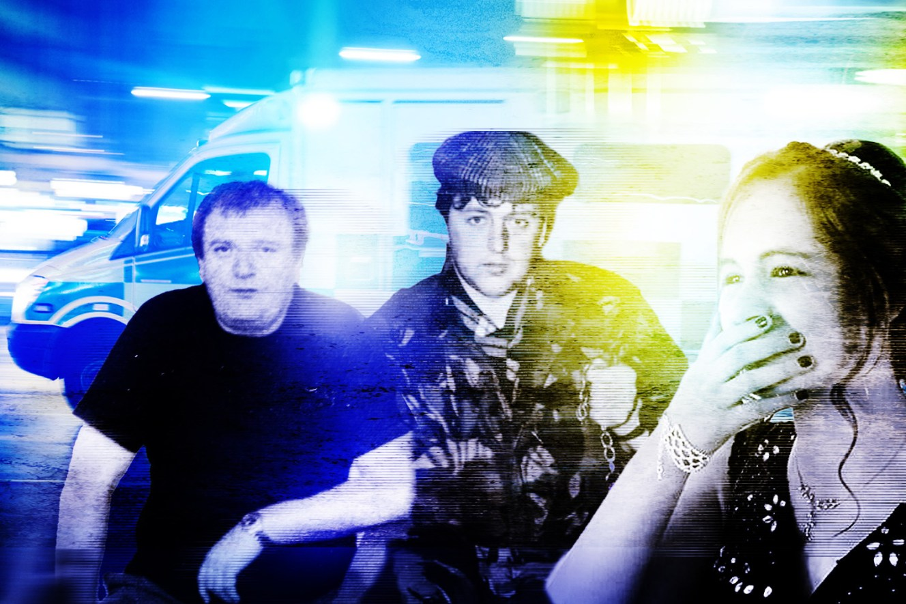Left and centre, Peter Coates and Norman Thompson died while waiting for an ambulance. Right, Quinn Evie Beadle
NHS managers within the service set up a group in 2019 called Seacare that was supposed to make more efficient and timely the process of disclosing documents to the coroner via the service’s team of coroner’s officers. The coroner would use such evidence to determine whether an inquest should take place.
But Calvert claims that Seacare was simply used to sift out “inconvenient facts” about blunders before they got into the public domain.
Calvert claims he saw paramedics and others bullied into changing witness statements to protect the NEAS’s reputation and prevent families from complaining. In Quinn’s case, he says a consultant paramedic altered evidence and believes her family were purposely kept in the dark about mistakes.
Advertisement
He threatened managers that he would go to her family directly, as well as the media, if they did not investigate more than 30 cases he had concerns about at the time.
“The managers had no choice,” Calvert said. “They had to agree to an audit.”
The same year, an external auditor looked at six out of 30 cases supplied by coroner’s officers at the service. The report confirmed Calvert’s claims: documents were altered, suppressed and concealed from the families of patients who had died during 999 call-outs.
Last week, The Sunday Times revealed how service managers had altered files to hide staff mistakes from coroners and grieving families. In one case, a 62-year-old man died after his oxygen machine cut out. NHS leaders withheld evidence that would have explained a 34-minute delay was caused by an ambulance crew being unable to operate the ambulance bay’s gates. The call went to a second crew further away, which stopped off for petrol on the way to his house, despite the ambulance having enough fuel to make the journey. By the time they arrived, he had suffocated.
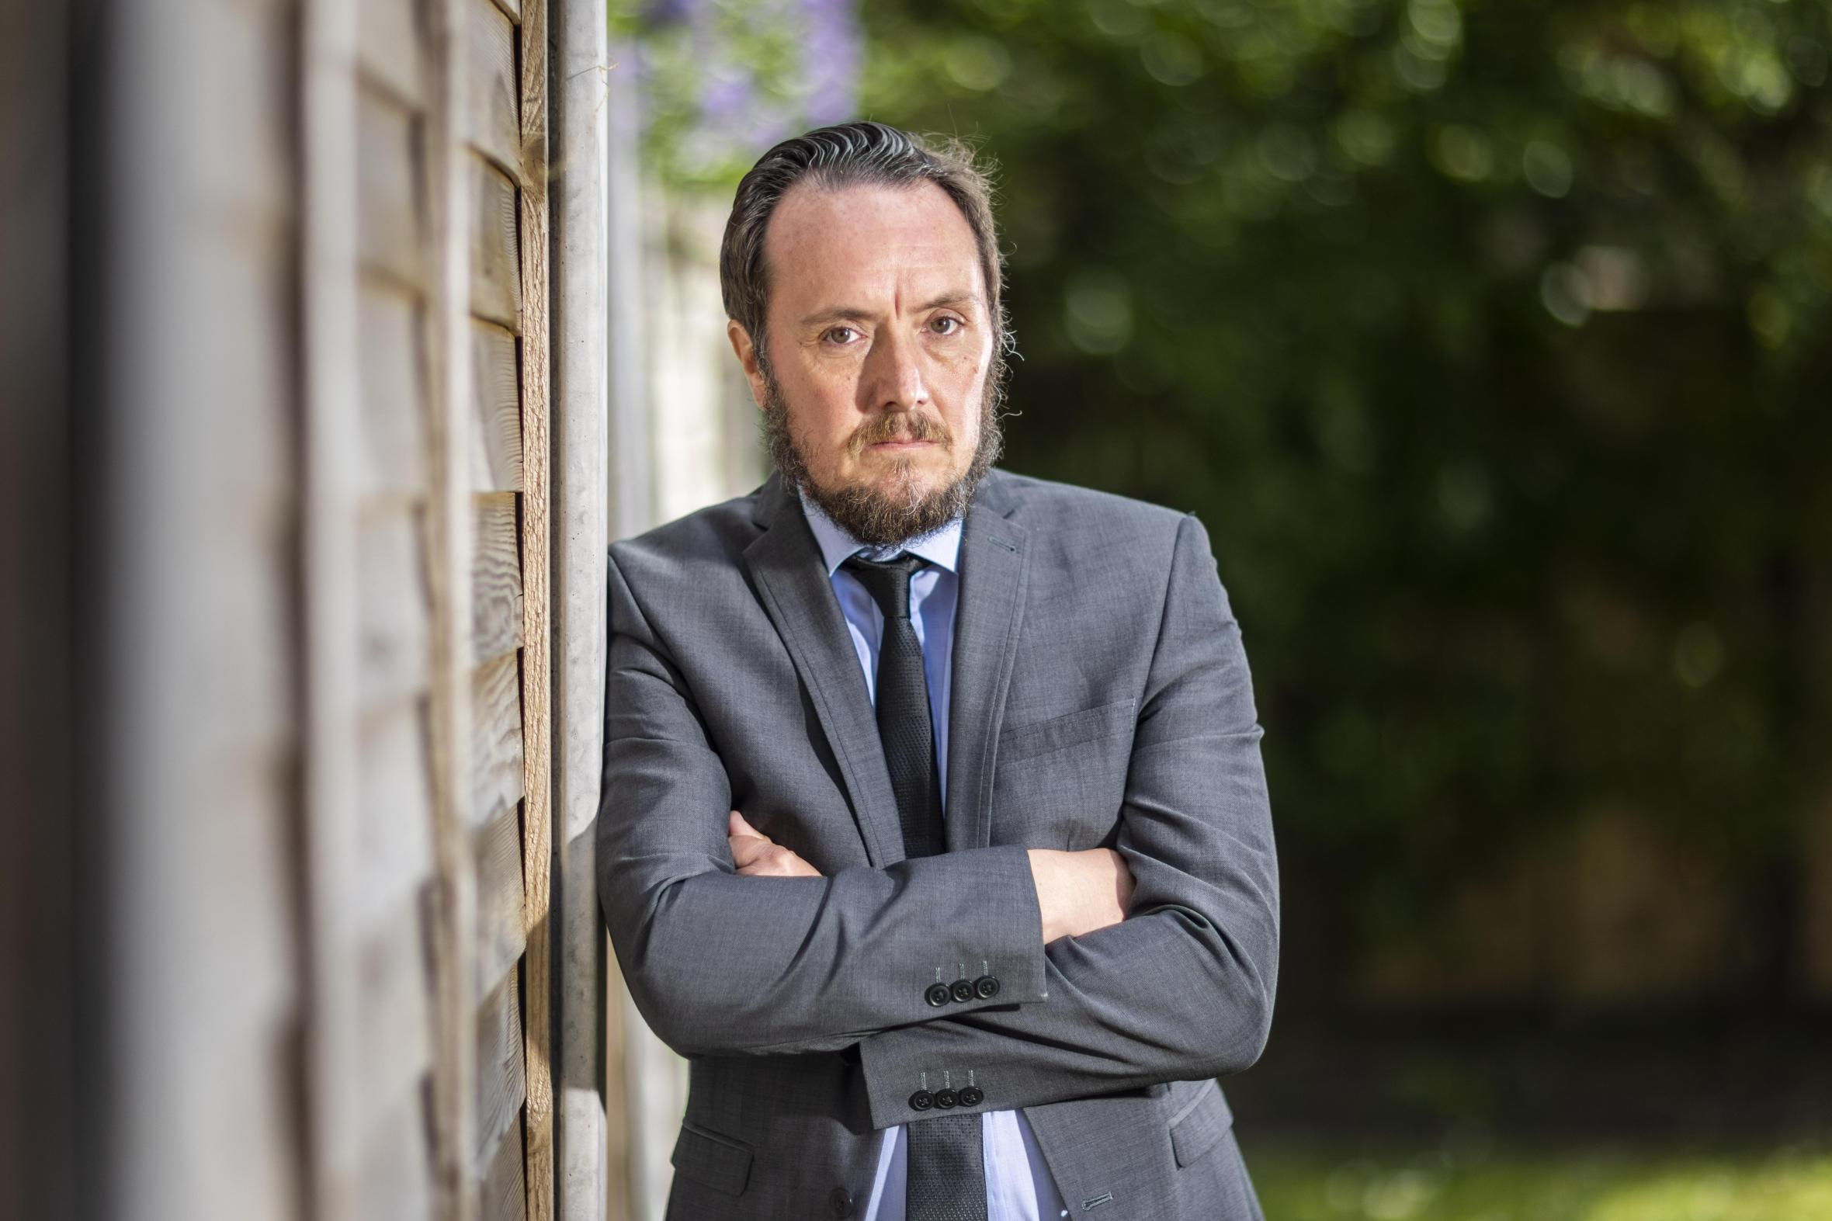Paul Calvert, a former coroner’s officer, said malpractice was a daily eventANDREW MCCAREN FOR THE SUNDAY TIMES
Calvert said the manipulation of evidence relating to the deaths of people who had called 999 was a “daily occurrence”.
Advertisement
He said he once spoke to a “crying” member of female staff who had been tasked with altering background investigation reports when complaints came in from families. “The malpractice was on a daily basis,” he said. “Concealing, destroying, not supplying things when we should be. It would happen every day. I couldn’t keep up with it.”
He called one of the people with responsibility for the coroner’s officers “Captain Cover-up”. “He was like a double agent for the service,” Calvert said. “He would listen to you, agree, and then come back from meetings with the NHS bosses with a completely different story. If something needed covering up, he was your man.”
Calvert provided the police and external auditors with evidence of senior paramedics being instructed to order their juniors to make damning witness statements “disappear”.
One paramedic told him bosses had ordered him to get a junior member of staff to change their witness statement to scrub blunders during an emergency call.
Calvert complained he was being bullied by managers who were telling him to keep quiet. The service’s chief executive, Helen Ray, who earns £150,000 a year, wrote to him in May 2020: “It was evident that you and your colleagues have attempted to raise your concerns on more than one occasion from April to June 2019.” Ray acknowledged his whistleblowing had “had a negative impact upon your health and wellbeing”. She thanked him for his “unwavering desire” to help the service fulfil its legal duties, and laid out changes she had made as a result of his complaints.
Advertisement
But Calvert said nothing had changed at the service up to the point he walked out of headquarters on July 8 last year. This year, he and a colleague were offered non-disclosure agreements. Calvert refused to sign because of the “gagging” clause that would have prevented further disclosures to police and the Care Quality Commission.
Last week, families whose loved ones died demanded the ambulance trust tell the full truth. Nigel Mitchell, 62, lost his wife Gill, 63, after she suffered a heart attack in October. Mitchell called 999 and told the operator his wife needed urgent assistance. He asked for a helicopter.
“Their first retort was, ‘We don’t just get the helicopter for anybody’,” he said. He drove her to a nearby village with a defibrillator.
By the time help arrived — four ambulances and a helicopter — it was too late. He believes the call was not prioritised and wants the NEAS to come clean.
“It’s their duty to tell the families that they’ve made a balls-up,” he said. “That’s the least they could do, isn’t it? If they have any bit of decency left in their souls, they would do that.”
Advertisement
Ray said: “Utmost in our minds are the families affected and we unreservedly apologise for the distress we have caused to them.
“We had a number of issues, dating back to 2019, which meant we needed to fully review and revise our reporting mechanisms.” She said the concerns had been acted upon and she was confident the system now in place was “robust”.
UKHealthcare
Share

