These are the CQC Freedom To Speak Up Guardian reports which have been published so far amongst the board papers, with some core findings:
CQC Freedom To Speak Up Guardian report 13 June 2018
“There have been 35 concerns raised to the year ending March 2018 with the vast majority relating to the behaviour of managers and colleagues. Two cases have been formally investigated and four have resulted in grievances and Personal Development Review appeals. The remainder have been resolved informally or are ongoing.”
CQC Freedom To Speak Up Guardian report 12 December 2018
“At the half way point in the year 23 people had come forward seeking support to speak up, this is broadly comparable with the same stage last year. Concerns about the behaviour of colleagues and managers, including concerns about harassment, account for the majority. There were also concerns about the time taken to investigate complex grievances and the way in which some decisions around major changes have been handled and communicated.”
CQC Freedom To Speak Up Guardian report 10 June 2020

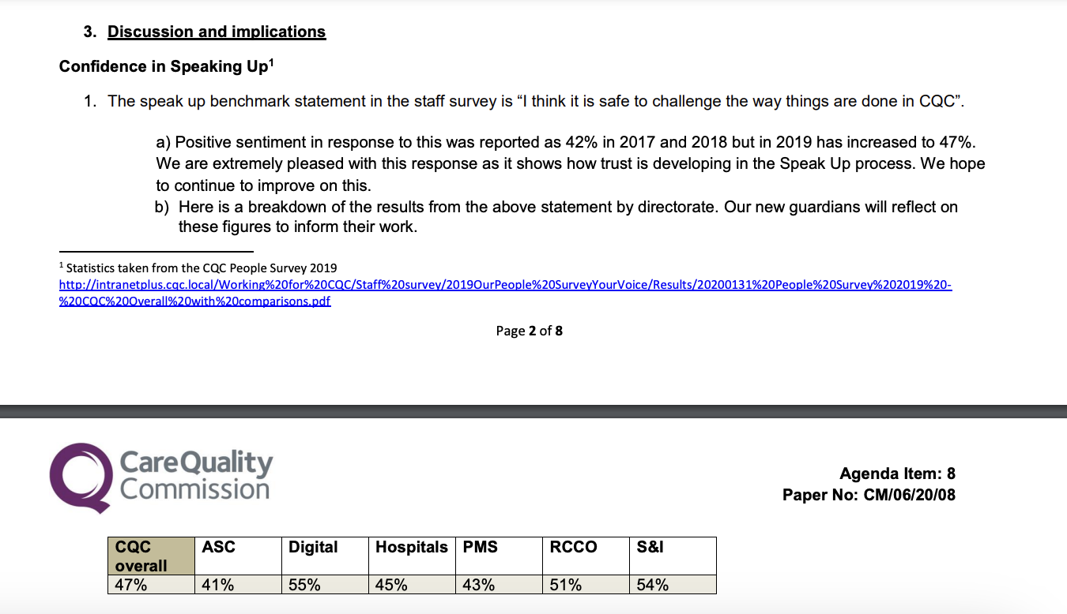
“We now use a webform to allow Ambassadors to submit information regarding each case they handle in a manner that protects this sensitive data. Here we have presented some key analysis from the 2019 cases. 33 cases were recorded on our speak up tracker for 2019.”
CQC Freedom To Speak Up Guardian report 21 October 2020
“In the past 6 months, we have received 15 contacts through the Freedom to Speak Up route. The number of contacts is too small to provide any meaningful analysis and interpretation at this juncture. We have seen an increase in the number of people contacting us with concerns since we joined one of Ian’s “All Staff Calls.” Some of the contacts we have received simply needed reassurance or signposting and we can see how things have come about due to misunderstandings of messages. We have been actively making sure anyone who has contacted us has received feedback and support. We have had two concerns from Whistleblowers which resulted in formal investigations”
CQC Freedom To Speak Up Guardian report 21 April 2021
Since April 2020 there have been 40 recorded concerns/cases reported through the speak up route. Of these, 50% were enquiries to Ambassadors or Guardians which were resolved by advice, signposting and/or informal routes for mediation. The remaining 50% resulted in investigations, through a formal complaint or grievance process. One contact resulted in a whistleblowing investigation…. Around a third of concerns raised related to issues about peers and mainly related to team culture of perceived bullying or behaviours not in keeping with CQC values. 23% of concerns raised related to perceived bullying by manager and managers not providing enough support. A fifth of concerns were about organisational issues such as policies needing to be implemented more effectively. We also had a fifth of concerns raised by about lower grades…. In most cases there has been resolution either through an indirect approach or a more formal approach involving HR and the grievance process. Some cases are still ongoing.
We have been working closely with HR to ensure that we can signpost colleagues with concerns to the appropriate resolution routes. There are times when issues are raised through the Speak Up route which need to be passed through to be addressed via HR policies and procedures.”

