Freedom to speak up:
raising concerns (whistleblowing) policy
  - Document Control Sheet
Version Number | 04
Document Author | Trust Secretary
Head of Department/Executive Director Job Title | Director of People and Development / FTSU Executive Lead
Date Approved | 18 November 2019
Date Form Effective From | 17 December 2019
Next Review Date | 18 November 2022
Keywords | Whistleblowing, concern, public interest, guardian, safety, confidentiality, investigation, patient care,
Target Audience | All staff, volunteers and students

Unless this copy has been taken directly from the Trust’s policy system there is no assurance that this is the most up to date version.





Version Control - Table of Revisions
NHS Improvement
NHS England
Freedom to speak up:
raising concerns (whistleblowing) policy

All changes to the document must be recorded within the ‘Table of Revisions’.
Version number | Document section/ page number | Description of change and reason (e.g. initial review by author/ requested at approval group | Author/ Reviewer | Date revised
01 | Full review | Adoption of the national policy which has been tailored to incorporate local leads and contact details | Trust Secretary | May 2016
02 | Partial review | Minor updates made to reflect: new Non-Executive Director lead, the new Champions role, new email address for the Guardian; and the link to the Charity Commission for concerns relating to the Charitable Fund.  Note that the review dates and period have not been amended as the policy has not undergone a full review. | Trust Secretary | December 2017
03 | Full review | A full review of the policy has been undertaken. This policy follows the format of the national NHS Improvement / England model policy. Revisions have been made in line with the National Guardian’s Office’s policy review guide. This includes removing references to malicious allegations and broadening the scope of the concerns considered under Freedom to Speak Up. | Trust Secretary / Freedom to Speak Up Guardian | November 2019
04 | Partial review | Contact details updated to reflect the change in Guardian. | Trust Secretary | June 2021

Contents
Speak up – we will listen 5
This policy 5
What concerns can I raise? 6
Feel safe to raise your concern 6
Confidentiality 6
Who can raise concerns? 7
Who should I raise my concern with? 7
Advice and support 8
How should I raise my concern? 8
What will we do? 8
Raising your concern with an outside body 9
Annex A: North East Ambulance Service NHS Foundation Trust - local process for raising and escalating a concern 11
Annex B: A vision for raising concerns in the NHS 13

Speak up – we will listen
Speaking up about any concern you have at work is really important. In fact, it’s vital because it will help us to keep improving our services for all patients and the working environment for our staff.
You may feel worried about raising a concern, and we understand this. But please don’t be put off. In accordance with our duty of candour, our senior leaders and entire Board are committed to an open and honest culture. We will look into what you say and you will always have access to the support you need.

This policy
This ‘standard integrated policy’ was one of a number of recommendations of the review by Sir Robert Francis into whistleblowing in the NHS, aimed at improving the experience of whistleblowing in the NHS. It is expected that this policy (produced by NHS Improvement and NHS England) will be adopted by all NHS organisations in England as a minimum standard to help to normalise the raising of concerns for the benefit of all patients.
Our local process has been integrated into the policy/adheres to the principles of this policy and provides more detail about how we will look into a concern – see Appendix A.
This policy covers both North East Ambulance Service NHS Foundation Trust and its subsidiary company North East Ambulance Service Unified Solutions.

What concerns can I raise?
You can speak up about matters that concern you, problems, issues or things you think we could improve. We encourage you to speak up and thank you for doing so.
You can raise a concern about risk, malpractice or wrongdoing you think is harming the service we deliver. Just a few examples of this might include (but are by no means restricted to):
- unsafe patient care
- unsafe working conditions
- inadequate induction or training for staff
- lack of, or poor, response to a reported patient safety incident
- suspicions of fraud (which can also be reported to our local counter-fraud specialist on 0191 5699665 or 07990 587246. Please see the Trust’s Trust’s Anti-Fraud, Bribery and Corruption Policy for further details).
- a bullying culture (across a team or organisation rather than individual instances of bullying).
For further examples, please see the Health Education England video.
Remember that if you are a healthcare professional you may have a professional duty to report a concern. If in doubt, please raise it.
Don’t wait for proof. We would like you to raise the matter while it is still a concern. It doesn’t matter if you turn out to be mistaken as long as you are genuinely troubled.
We describe Freedom to Speak Up as a safety net here at NEAS and NEASUS. There are lots of different processes and routes for raising concerns, for example through incident reporting or grievance processes. We understand that sometimes these routes may not be appropriate to use for specific concerns, or staff may not feel they have worked effectively. Freedom to Speak Up acts as a safety net to support staff who feel they need to escalate their concerns outside of the normal line management / reporting procedures.

Feel safe to raise your concern
We will not tolerate the harassment or victimisation of anyone raising a concern. Nor will we tolerate any attempt to bully you into not raising any such concern. Any such behaviour is a breach of our values as an organisation and, if upheld following investigation, could result in disciplinary action.

Confidentiality
We hope you will feel comfortable raising your concern openly, but we also appreciate that you may want to raise it confidentially. This means that while you are willing for your identity to be known to the person you report your concern to, you do not want anyone else to know your identity.
Where requested confidentiality will be preserved wherever possible. Confidentiality will be preserved unless disclosure of information in confidence is required by law.
You can choose to raise your concern anonymously, without giving anyone your name, but that may make it more difficult for us to investigate thoroughly and give you feedback on the outcome.

Who can raise concerns?
Anyone who works (or has worked) in the NHS, or for an independent organisation that provides NHS services can raise concerns. This includes agency workers, temporary workers, students, volunteers and governors.

Who should I raise my concern with?
In many circumstances the easiest way to get your concern resolved will be to raise it formally or informally with your line manager (or lead clinician or tutor). We would encourage you to do so as a first step, but we recognise that this is not always appropriate or may not always lead to effective resolution. In this scenario you can use any of the options set out below in the first instance.
If raising it with your line manager (or lead clinician or tutor) does not resolve matters, or you do not feel able to raise it with them, you can contact one of the following people:
- our Interim Freedom to Speak Up Guardian, Paula Gent (paula.gent@neas.nhs.uk) – this is an important role identified in the Freedom to Speak Up review to act as an independent and impartial source of advice to staff at any stage of raising a concern, with access to anyone in the organisation, including the Chief Executive, or if necessary, outside the organisation. The Freedom to Speak Up Guardian can also be contacted via the Freedom to Speak Up inbox: ftsu@neas.nhs.uk. Please note that if you write to the Guardian at Trust Headquarters, we cannot guarantee that post will not be opened by another member of staff due to the remote working arrangements in place.
If you still remain concerned after this, you can contact:
- our Executive Director with responsibility for Freedom to Speak Up – Karen O’Brien, Director of People and Development on Karen.OBrien@neas.nhs.uk.
- our Non-Executive Director with responsibility for Freedom to Speak Up – Carolyn Peacock on carolyn.peacock@neas.nhs.uk.
- our Chief Executive, Helen Ray on helen.ray@neas.nhs.uk
All these people have been trained in receiving concerns and will give you information about where you can go for more support.
If for any reason you do not feel comfortable raising your concern internally, you can raise concerns with external bodies, listed on pages 8 and 9.

Advice and support
Details on the local support available to you can be found here http://neasintranet.neas.northy.nhs.uk/. However, you can also contact the Whistleblowing Helpline for the NHS and social care, your professional body or trade union representative.

How should I raise my concern?
You can raise your concerns with any of the people listed above in person, by phone or in writing (including email).
Whichever route you choose, please be ready to explain as fully as you can the information and circumstances that gave rise to your concern.

What will we do?
We are committed to the principles of the Freedom to Speak Up review and its vision for raising concerns, and will respond in line with them (see Annex B).
We are committed to listening to our staff, learning lessons and improving patient care. On receipt the concern will be recorded and you will receive an acknowledgement within two working days.
Investigation
Where you have been unable to resolve the matter quickly (usually within a few days) with your line manager, we will carry out a proportionate investigation – using someone suitably independent (usually from a different part of the organisation) and properly trained – and we will reach a conclusion within a reasonable timescale (which we will notify you of). Wherever possible we will carry out a single investigation (so, for example, where a concern is raised about a patient safety incident, we will usually undertake a single investigation that looks at your concern and the wider circumstances of the incident). The investigation will be objective and evidence-based, with a focus on identifying and rectifying any issues, and learning lessons to prevent problems recurring.
We may decide that your concern would be better looked at under another process; for example, our process for dealing with bullying and harassment. If so, we will discuss that with you.
Communicating with you
We will treat you with respect at all times and will thank you for raising your concerns. We will discuss your concerns with you to ensure we understand exactly what you are worried about. We will tell you how long we expect the investigation to take and keep you up to date with its progress. Wherever possible, we will share the full investigation report with you (while respecting the confidentiality of others).
How will we learn from your concern?
The focus of the investigation will be on improving the service we provide for patients. Where it identifies improvements that can be made, we will track them to ensure necessary changes are made, and are working effectively. Lessons will be shared with teams across the organisation, or more widely, as appropriate.
Board oversight
The People & Development Committee and Board will be given high level information about all concerns raised by our staff through this policy and what we are doing to address any problems. The Board supports staff raising concerns and wants you to feel free to speak up.
Review
We will review the effectiveness of this policy and local process at least every three years, with changes made as appropriate.

Raising your concern with an outside body
Alternatively, you can raise your concern outside the organisation with:
- NHS I/E for concerns about:
    - how NHS trusts and foundation trusts are being run
    - other providers with an NHS provider licence
    - NHS procurement, choice and competition
    - the national tariff
    - primary medical services (general practice)
    - primary dental services
    - primary ophthalmic services
    - local pharmaceutical services
- Care Quality Commission for quality and safety concerns
- Health Education England for education and training in the NHS
- NHS Counter Fraud Authority for concerns about fraud and corruption.
- Charity Commission for concerns relating to our Charitable Fund.

Making a ‘protected disclosure’
There are very specific criteria that need to be met for an individual to be covered by whistleblowing law when they raise a concern (to be able to claim the protection that accompanies it). There is also a defined list of ‘prescribed persons’, similar to the list of outside bodies on pages 8 and 9, who you can make a protected disclosure to. To help you consider whether you might meet these criteria, please seek independent advice from the Whistleblowing Helpline for the NHS and social care, Public Concern at Work or a legal representative.

National Guardian Freedom to Speak Up
The National Guardian can independently review how staff have been treated having raised concerns where NHS trusts and foundation trusts may have failed to follow good practice, working with some of the bodies listed above to take action where needed. Further information about the National Guardian can be found here: National Guardian's Office

Annex A: North East Ambulance Service NHS Foundation Trust - local process for raising and escalating a concern
Step one – seeking advice and raise your concern informally
If you have a concern about a risk, malpractice or wrongdoing at work, we hope you will feel able to raise it first with your line manager, lead clinician or tutor (for students). This may be done orally or in writing.
Step two – seeking advice and raising formally
If you feel unable to raise the matter with your line manager, lead clinician or tutor, for whatever reason, or they are unable to satisfactorily resolve the issue, please raise the matter with our Interim Freedom to Speak Up Guardian: Paula Gent (contact details are included in the policy).
This person has been given special responsibility and training in dealing with Freedom to Speak Up concerns. They will:
- treat your concern confidentially unless otherwise agreed
- ensure you receive timely support to progress your concern
- escalate to the Board any indications that you are being subjected to detriment for raising your concern
- remind the organisation of the need to give you timely feedback on how your concern is being dealt with
- ensure you have access to personal support since raising your concern may be stressful.
If you want to raise the matter in confidence, please say so at the outset so that appropriate arrangements can be made.
Step three – escalating your concern
If these channels have been followed and you still have concerns, or if you feel that the matter is so serious that you cannot discuss it with any of the above, please contact the Director of People and Development, Non-Executive Director with responsibility for Freedom to Speak Up, or ultimately the Chief Executive. Please see the policy content for contact details.
Step four – escalating externally
If your concerns are not resolved at step 3 you may wish to raise your concerns formally with an external body. Always seek additional advice and support before deciding to raise a concern externally. As outlined in the policy, depending on the nature of the concern you may wish to raise it with:
- NHS Improvement
- Care Quality Commission
- NHS England
- Health Education England
- NHS Counter Fraud Authority
- Charity Commission (where concerns relate to our Charitable Fund)
Please note that independent advice is also available via the National Whistleblowing Helpline on 0800 0724725. For independent advice in relation to child protection issues you can contact the NSPCC Whistleblowing Advice Line on 0800 028 0285.

Annex B: A vision for raising concerns in the NHS
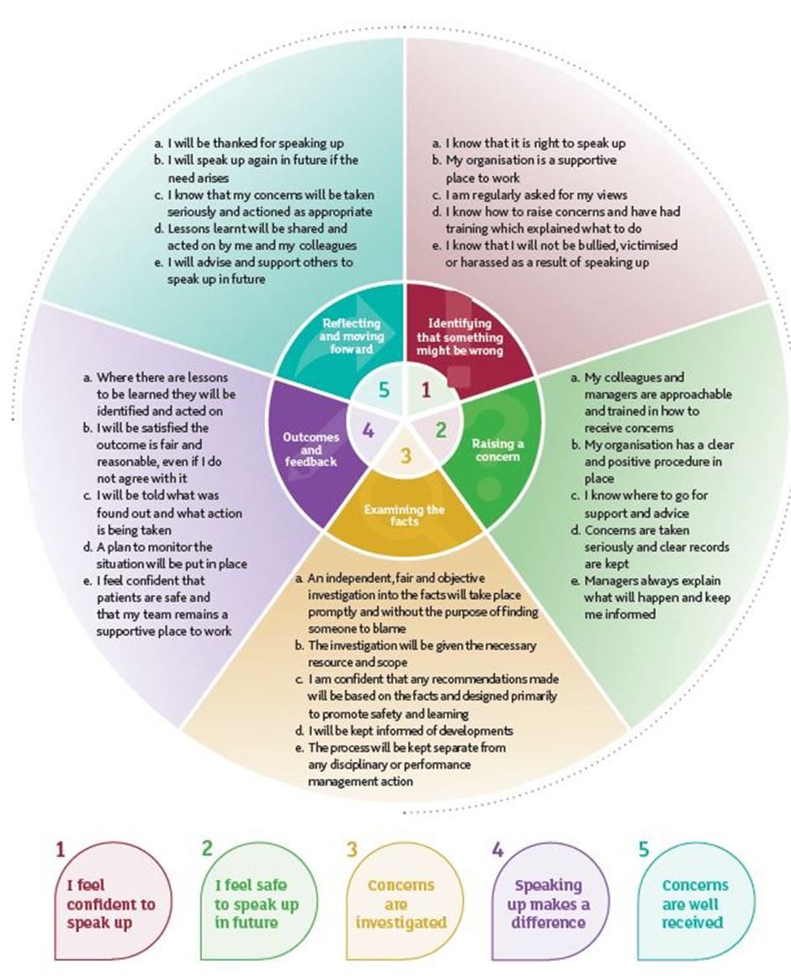
Source: Sir Robert Francis QC (2015) Freedom to Speak Up: an independent report into creating an open and honest reporting culture in the NHS.
NHS Improvement is the operational name for the organisation that brings together Monitor, NHS Trust Development Authority, Patient Safety, the National Reporting and Learning System, the Advancing Change Team and the Intensive Support Teams.

This publication can be made available in a number of other formats on request.

© NHS Improvement (April 2016) Publication code: Policy 01/16
Publications Gateway Reference: 04877
NHS Improvement
Wellington House
133-155 Waterloo Road
London
SE1 8UG

T: 020 3747 0000
E: nhsi.enquiries@nhs.net
W: improvement.nhs.uk
W: improvement.nhs.uk
W: improvement.nhs.uk
NHS Improvement
NHS England
Contact us

The difference between raising your concern formally and informally is explained in our local process – see Annex A.
If your concern suggests a Serious Incident has occurred, an investigation will be carried out in accordance with the Serious Incident Framework.

