https://www.eadt.co.uk/news/nhs-investigation-in-to-west-suffolk-hospital-whistleblowing-1-6488302

Calls for inquiry into alleged 'witch-hunt' at hospital
PUBLISHED: 11:49 29 January 2020 | UPDATED: 11:49 29 January 2020
Oliver Sullivan

West Suffolk Hospital. Picture: GREGG BROWN

An urgent inquiry should be carried out into a so-called "witch-hunt" at West Suffolk Hospital following a whistleblowing incident, the government has said.




Share
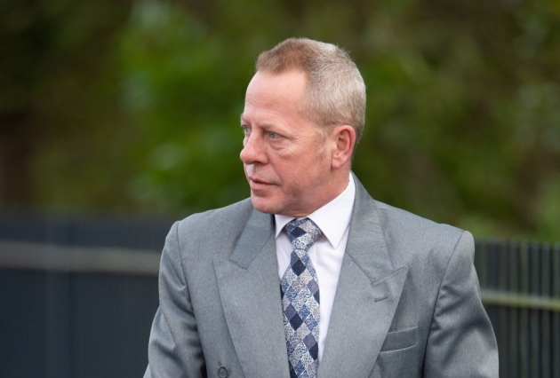Susan Warby's husband Jon Warby said he was 'knocked sideways' by the letter Picture: JOE GIDDENS/PA WIRE
The call from the Department of Health and Social Care (DHSC) comes after the death mother-of-two Susan Warby, who died five weeks after a bowel operation carried out at the hospital.
In the wake of her death, Mrs Warby's family received an anonymous letter raising concerns over what happened during the procedure - prompting the hospital to ask doctors asked for their fingerprints and handwriting samples in a bid to identify who blew the whistle.
The hospital had previously argued the investigation was deemed to be carried out with "clear reasoning" and "good practice" by the national head of whistleblowing for the NHS and added allegations of staff bullying are taken "very seriously".
MORE: Hospital criticised over "witch-hunt" after whistleblowing incident
At the inquest into Mrs Warby's death, coroner Nigel Parsley called for the police and hospital to carry out their own investigations.
The full reference terms of the DHSC inquiry will be confirmed in the coming days.
However health secretary Matt Hancock has said he will not be involved in the review, which is near to West Suffolk constituency.
It will instead be carried out by health minister Edward Argar MP.
MORE: Husband of woman who died after bowel operation "knocked sideways" by letter
Bury St Edmunds MP Jo Churchill said she hopes reviews of the hospital will be carried out in a "timely way".
Mrs Churchill added: "I have seen first-hand the hard work and dedication of the staff at the West Suffolk Hospital, and the faith put in the hospital by my constituents to provide high quality care.
"However, where standards do fall below the expected level the hospital has a duty to launch a transparent and thorough investigation.
"Public safety should always be our priority and making sure that standards are always as high as they can be is imperative.
"When mistakes are made, we should learn from them, but a patient's right to privacy should always be respected."
A spokeswoman for West Suffolk Hospital said they are not prepared to comment on the inquiry until full reference terms have been announced by the DHSC.

