https://webcache.googleusercontent.com/search?q=cache:MV0kcoPE7_YJ:https://www.eadt.co.uk/news/hancock-backs-hospitals-1-6471624+&cd=1&hl=en&ct=clnk&gl=uk

Hancock insists Colchester and Ipswich hospitals are national trailblazers
PUBLISHED: 16:48 17 January 2020
Paul Geater

Matt Hancock met nursing staff at Colchester General. Picture; GREGG BROWN/ESNEFT

Health Secretary Matt Hancock has given the trust running hospitals in Colchester and Ipswich a major vote of confidence for the future just days after a CQC report said it needed improvement.




Share
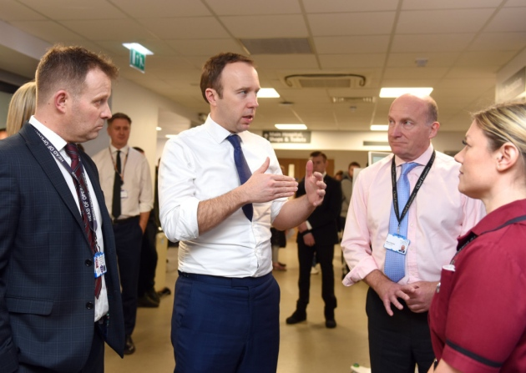Health Secretary Matt Hancock and chief executive Nick Hulme with staff at Colchester General. Picture: GREGG BROWN/ESNEFT
Mr Hancock praised the leadership of the East Suffolk and North Essex NHS Foundation Trust as one of the best in the country despite the CQC report.
And he said a new way of dealing with emergency admissions being used at Colchester could be a blueprint for other hospitals across the country.
The Emergency Department there - which is due to have a major makeover in the near future - has managed to reduce the number of patients waiting more than four hours for treatment.
It has an urgent treatment centre staffed by GPs to see patients who may not need to be admitted as emergencies and a new Acute Medicine Same Day Emergency Care (AMSDEC) centre.
AMSDEC rapidly investigates and treats suitable patients who have been referred by their GP, the ambulance service or other hospital departments without the need for them to go to the Emergency Department first.
Its aim is to provide them with the right care so that they can return home the same day, reducing unnecessary admissions.
There had been concerns that the merger of the two hospitals into one trust could lead to Ipswich - which has been highly-rated over recent years - being dragged down by Colchester which has had problems.

You may also want to watch:
Local council election results are in for Ipswich and Colchester
All the results you need to know from Ipswich and Colchester's local council elections. Powered by the EADT and Ipswich Star, Suffolk Now is the YouTube channel for all of the best stories from across Suffolk, North Essex and the eastern region, bringing you the latest in news, sport, special features and great live content.
Volume 90%
Watch more local videos
Local council election results are in for Ipswich and Colchester
New look planned for Colchester Hospital
Man dead after stabbing in Colchester
Home Secretary Priti Patel in Ipswich
Ipswich Town Launch New Community Trust
GE 2019: Will Quince reacts after holding his Colchester seat for the Conservatives
Mr Hancock rejected these fears: "Ipswich has one of the strongest hospital leaderships in the country and that is now benefitting Colchester. Seeing what is happening there shows that by merging they are both stronger than they would be individually.
"This new way of dealing with emergency admissions has been very successful and will be extended to hospitals across the country in due course."
Mr Hancock said the presence of GPs in the treatment centre at Colchester allowed it to care for some patients who did not need to be admitted: "That frees the emergency department to deal with the very serious cases.
"The emergency department is due to be given a major investment, but it has already seen a great improvement in the way it is able to treat patients quickly and efficiently."
He said this was a process that could be rolled out to other hospitals including Ipswich where a new emergency unit including an urgent treatment centre is due to be built very soon.
The AMSDEC centre is also being trialled at Ipswich and Mr Hancock said the three elements of the emergency department could be seen as a blueprint for other hospitals across the country.
He said: "This is certainly the kind of thing that could work all over the country - in places like the new West Suffolk Hospital."
The Health Secretary was shown round the departments by Nick Hulme, the chief executive of the East Suffolk and North Essex NHS Foundation Trust which runs the major hospitals in Ipswich and Colchester. He also met 30 staff from across Colchester General to answer questions about the development of NHS and their own hospital.
Mr Hulme said: "It was great to welcome the Secretary of State to the hospital where he thanked the staff for their extraordinary work over the winter.
"We were delighted to be able to show him our urgent and emergency departments, including our new urgent treatment centre which provides us with an innovative way of caring for patients with urgent conditions."

