Speech by Dr David Nicholl at a Change Uk event May 2019:

https://www.youtube.com/watch?v=FcYeEkBCtsw&feature=youtu.be

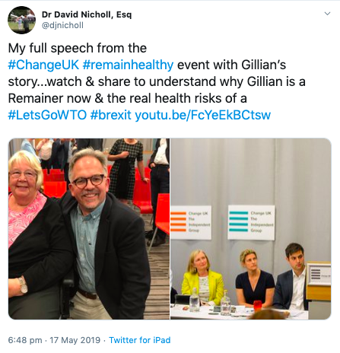

https://www.stourbridgenews.co.uk/news/17528370.dr-david-nicholl-to-take-on-mp-sajid-javid-over-brexit/

26th March 2019

Dr David Nicholl to take on MP Sajid Javid over Brexit

By Bev Holder @StourbridgeNewsChief Reporter/Data Investigations Reporter
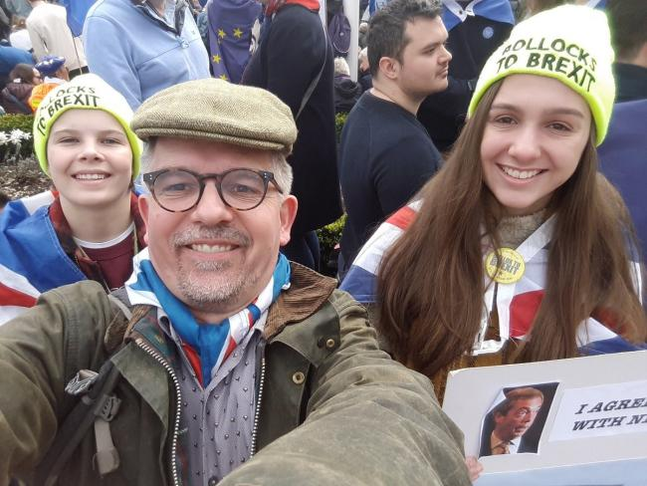
Dr David Nicholl and his daughters Jose and Isobel at the People's March
2 comments
A CAMPAIGNING Hagley doctor says he will put himself forward to stand as a candidate against his own MP - Home Secretary Sajid Javid - if a no deal Brexit is not ruled out.
Dr David Nicholl, who attended the People's March in London on Saturday calling for the public to be given a final say on Brexit, said he is worried about the risk to patients should Britain crash out of the EU without a deal and he is urging Bromsgrove MP Mr Javid to rule it out.
He said: "I'm appalled that my MP has refused to remove no deal from the table. Any MP that supports no deal is nutty in terms of what I've seen."
Dr Nicholl, a Birmingham based consultant neurologist, said he's concerned patients will be at risk of "inferior health care" in the event of a no deal scenario and he added: "This is not operation fear - it's operation I've seen the Excel file."
The doc, however, is unable to reveal further details as he says he has been made the subject of a non-disclosure agreement (NDA) regarding Department of Health and Social Care preparations for a no deal Brexit - and he said: "I'm not impressed. There is certainly no reason for any of this to be subject to an NDA other than political reasons. NDAs were meant to be banned in 2013."
He said MPs refusing to rule out no deal were "putting party politics ahead of their own constituents" and he added: "I'm really quite concerned about the risk of no deal. I think it should be removed immediately."
To show how worried he is about the prospect of no deal - Dr Nicholl has also written to Independent Group MP Sarah Woolaston and offered to stand against his own MP, Home Secretary Sajid Javid who represents Bromsgrove, as a candidate for the Independent Group (TIG) should a general election be called.
He said: "I'm quite happy to stand as an independent group candidate against Sajid Javid if he persists with no deal. "My offer is there - it's genuine. I think things have got to the point where senior NHS people need to call out the no deal malarkey as unsafe."
Dr Nicholl, aged 54, and his daughters Isobel, aged 18, and Jose, aged 13, were among the estimated one million people who took part on Saturday in the Put It To The People march from Park Lane to Parliament Square to call for another EU referendum.
Sajid Javid's office had not responded for comment at time of publishing.
