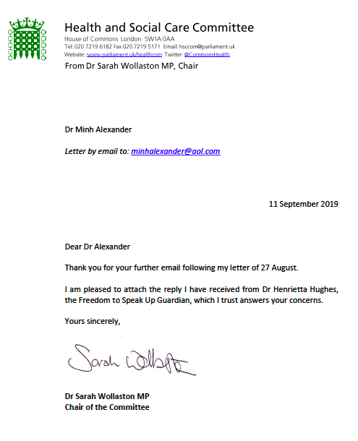

From: Health and Social Care Committee <REDACTED>
Subject: RE: UK government does not track whether whistleblowers’ concerns are addressed but claims lives are being saved
Date: 11 September 2019 at 10:23:37 BST
To: Minh Alexander <REDACTED>
Cc: Health and Social Care Committee <REDACTED>

Please find attached a reply from Dr Wollaston to the email below, together with an attachment.

Huw Yardley
Clerk, Health and Social Care Committee
House of Commons | London | SW1A 0AA
hsccom@parliament.uk | Tel: 020 7219 6182
www.parliament.uk/healthcom | @CommonsHealth | @houseofcommons

Supporting a thriving parliamentary democracy

From: Minh Alexander <REDACTED >
Subject: UK government does not track whether whistleblowers’ concerns are addressed but claims lives are being saved
Date: 29 August 2019 at 10:51:32 BST
To: Sarah Wollaston <REDACTED >
Cc: REDACTED

BY EMAIL

Dr Sarah Wollaston
Chair of Health and Social Care Committee

28 August 2019

Dear Dr Wollaston

UK government does not track whether whistleblowers’ concerns are addressed but claims lives are being saved

Thank you for your letter yesterday replying to my enquiry of 9 August 2019, both copied below, and your offer to seek an update on whether the NHS National Freedom To Speak Up Guardian will in future track whether whistleblowers’ concerns are addressed.

I would be grateful if you would do so.

You will recall that I asked the Committee to consider this issue last September.

The situation now is very serious, because not only is the National Guardian continuing to fail to track whether whistleblowers’ concerns are addressed, but she recently made unjustified claims that NHS Freedom To Speak Up Guardians were preventing “untold harm” and saving lives even though she still has no safe oversight of whether whistleblowers’ concerns are addressed.

This is correspondence with the National Guardian and her Office which revealed the lack of substantiating evidence for her claims about lives saved:

https://minhalexander.com/2019/08/25/the-low-fact-national-guardians-office/

Professor Sir Brian Jarman, an internationally acknowledged expert on mortality in healthcare made these observations about the lack of adequate evidence:

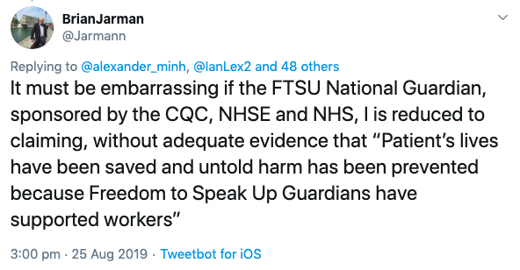

In addition to the concerns about the actions and omissions of the National Guardian’s Office, the Department of Health and Social Care maintains its silence on whether it will ensure that the Care Quality Commission has and uses clear powers to investigate individual whistleblowers’ concerns.

I was invited to attend a CQC event next month which included review of CQC’s policy and processes for handling whistleblowing, and sent relevant policy and guidance documents.

However, after I asked the DHSC to clarify its position on investigation of individual whistleblowers’ concerns in time for this consultation event, the CQC advised me and other whistleblowers that the scope of the event would be much narrower than originally advised in CQC’s invitation letter. Indeed, CQC told us emphatically:

"Therefore the event on the 2nd... will definitely not touch on our current guidance and your concerns about its current limitations."

I am concerned that the DHSC is continuing to control the narrative in an unhelpful way, and undermining any work to resolve the most fundamental flaw in Health & Social Care whistleblowing governance: the failure to reliably investigate individual whistleblowers’ concerns.

I hope that parliament will seek the clarity that is needed on this vital issue, in the interests of safeguarding the public.

It is an issue replicated across sectors, and reflects the un-rectified, central failure of UK whistleblowing law to compel investigation.

Yours sincerely,

Dr Minh Alexander

Cc Health and Social Care Committee
Meg Hillier
Barbara Keeley
Laura Pidcock
Anne Marie Trevelyan
Matt Hancock Secretary of State for Health
Caroline Dinenage Minister of State for Care

YOUR LETTER

"27 August 2019

Dear Dr Alexander

Thank you for your email of 9 August regarding the tracking of whether whistleblowers’ concerns are addressed.

Naturally, Dr Hughes, the National Guardian, shares my firm belief that matters raised by whistleblowers should be addressed appropriately. I understand that the National Guardian’s Office expects that organisations that receive whistleblowers’ concerns should have appropriate mechanisms for tracking them. The NGO’s office also considers that whistleblowers should receive feedback on what happens as a result of them raising an issue. That means not only being updated of the outcome of their report at the conclusion of the process, but also updates on how the matter is being progressed.

I note your view that the UK Government—and specifically the National Guardian’s office—should itself track whether whistleblowers’ concerns have been addressed. I do not have a further update on this issue from the National Guardian but I am happy to request one.

Yours sincerely,

Dr Sarah Wollaston MP
Chair of the Committee"

From: Health and Social Care Committee <REDACTED >
Subject: RE: UK government does not track whether whistleblowers’ concerns are addressed
Date: 27 August 2019 at 11:33:12 BST
To: Minh Alexander <REDACTED >
Cc: Health and Social Care Committee <REDACTED >

Please find attached a reply from Dr Wollaston to the email below.

Huw Yardley
Clerk, Health and Social Care Committee
House of Commons | London | SW1A 0AA
REDACTED| Tel: REDACTED

www.parliament.uk/healthcom | @CommonsHealth | @houseofcommons

Supporting a thriving parliamentary democracy

From: Minh Alexander <REDACTED >
Sent: 09 August 2019 08:43
To: WOLLASTON, Sarah <REDACTED >
Cc: <REDACTED>
Subject: UK government does not track whether whistleblowers’ concerns are addressed

BY EMAIL

Dr Sarah Wollaston
Chair of Health and Social Care Committee

9 August 2019

Dear Dr Wollaston,

UK government does not track whether whistleblowers’ concerns are addressed

I drew the Committee’s attention last year to the fact that the NHS National Guardian’s Office does not track whether whistleblowers’ concerns are addressed, as set out in the correspondence below.

You kindly indicated on 3 October 2018 - letter attached - that you would take this issue up with the National Guardian.

The National Guardian’s published data on Speaking Up still shows no sign of outcomes such as whether whistleblowers’ concerns are addressed:

https://www.cqc.org.uk/national-guardians-office/content/speaking-data

May I ask what response was received from the National Guardian when you raised this issue, and in light of the persisting lack of information on whether NHS whistleblowers’ concerns are addressed, what further action would the Committee be willing to take?

Please note that on a related matter, the Department of Health and Social Care is maintaining its long silence on whether the CQC should investigate individual whistleblowers’ concerns.

Yours sincerely,

Dr Minh Alexander

Cc Health and Social Care Committee
Caroline Dinenage MP for Gosport and Minister for Care
Barbara Keeley Shadow Minister for Mental Health and Social Care
Laura Pidcock Shadow Minister for Labour
Anne Marie Trevelyan MP

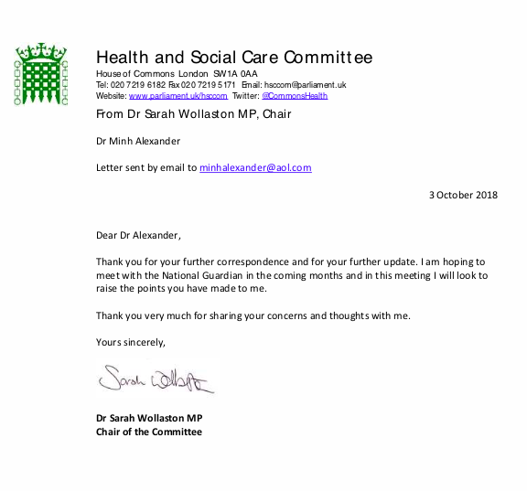

From: Health and Social Care Committee <REDACTED >
Subject: RE: UK government does not track whether whistleblowers’ concerns are addressed
Date: 3 October 2018 at 15:07:14 BST
To: Minh Alexander <REDACTED>

Dear Dr Alexander,

Please find attached a letter from the Chair of the Health and Social Care Committee, Dr Sarah Wollaston MP.

Kind regards,

Health and Social Care Committee
House of Commons | London | SW1A 0AA
Website: www.parliament.uk/hsccom
Twitter: @CommonsHealth

From: Minh Alexander <REDACTED >
Sent: 29 September 2018 11:24
To: Business, Energy and Industrial Strategy Committee <REDACTED>; REDACTED
Subject: UK government does not track whether whistleblowers’ concerns are addressed

BY EMAIL
BEIS Committee
Health and Social Care Committee
Public Accounts Committee
Public Administration and Constitutional Affairs Committee
Committee on Standards in Public Life
Joint Committee on Human Rights
29 September 2018

Dear Ms Reeves, Dr Wollaston, Ms Hillier, Mr Jenkin, CSPL Secretariat, Ms Harman and all other committee members,

UK government does not track whether whistleblowers’ concerns are addressed
I write to forward continuing evidence of the failure of current UK government policy on whistleblowing.

The NHS National Guardian’s Office and an underpinning network of internal Guardians within local NHS organisations, is held up by the UK government as a prototype.

The National Guardian’s Office acts as the secretariat for a pan-sector network on whistleblowing. It liaises with the financial sector and with other government agencies such as the MoD which also have internal whistleblowing ‘Champions’ and designated officers.

Neither local NHS Guardians nor the NHS National Guardian have statutory status nor powers. Neither does the National Guardian intend to seek a different remit.1

This sort of model is much opposed by whistleblowers and supporters, who know that it cannot effectively and reliably protect whistleblowers. A body of evidence continues to accumulate regarding this.

A key concern I wish to pass to you is the fact that the National Guardian’s Office collects limited staff feedback data, controlled and supplied by NHS trusts, and inexplicably neither collects nor publishes data on whether NHS staff’s concerns are addressed:
Another health check on the quality of the National Guardian's data

When questioned by the Health Service Journal, the Office advised ‘data was collected locally on how concerns were resolved’. I know from FOI data that this is only partially true. Some NHS trusts do not ask staff if their concerns have been addressed and others have admitted to collecting no staff feedback data at all.

This failure to check that whistleblower’s concerns are addressed seems to wholly conflict with the primary function of the Office to ensure safe and effective whistleblowing governance.

However, it does complement current UK whistleblowing policy as expressed in law through the Public Interest Disclosure Act, which does not compel anyone to investigate whistleblowers’ concerns. This is a huge failure of public protection.

The National Guardian’s Office's failure to collate data on whether whistleblowers’ concerns are addressed mirrors the conduct of the 2015 Freedom To Speak Up Review by Robert Francis for the Department of Health.

The report of the Review discussed extensively the fractious employment aspects of whistleblowing, but it did not report at all on the grave nature of protected disclosures that had never been addressed.

It is sobering that even after the revelation in June of hundreds of unnatural deaths at Gosport following suppression of whistleblowers, the only dedicated UK government whistleblowing agency – the National Guardian’s Office - shows disinterest in whether whistleblowers’ concerns are addressed.

Whistleblowing governance at Gosport in brief

The Gosport Inquiry released an internal memo of October 2002 by Sir Liam Donaldson CMO of which showed that the Department of Health became aware whistleblowers had raised concerns at Gosport in ‘the late 1980s/early 1990s’.

A 2003 Department of Health report released by the Gosport Inquiry referred to ‘tardy’ management response to the whistleblowers’ concerns:

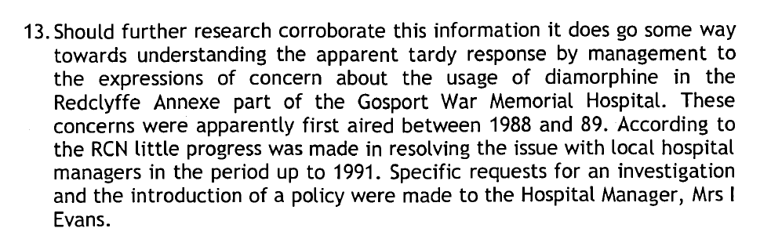

Disclosed records of a meeting on 17 December 1991 between the whistleblowers, managers, a Consultant Geriatrician and the doctor at the centre of concerns revealed minimisation, an emphasis on deference to authority, an instruction to confine further disclosures to the internal route and criticism of the whistleblowers.

The disaster that unfolded after the Gosport whistleblowers tried to raise the alarm but were ignored

Gosport Inquiry report page 27:

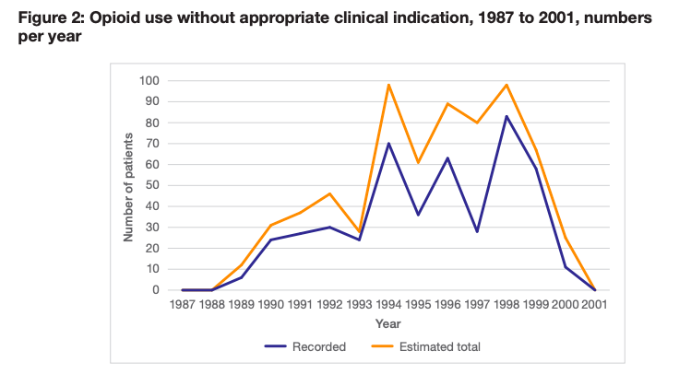

Gosport Inquiry report page 34:

Survival of those who were given continuous diamorphine without appropriate clinical indication: ‘59% were dead in two days or less.’

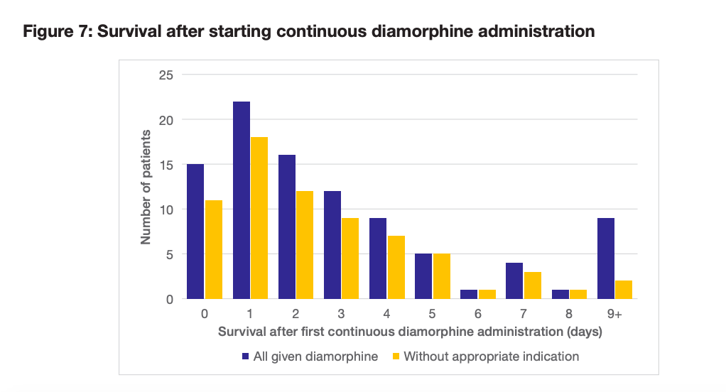

I hope that Parliament will recognise that it is time to end the last twenty years of fruitless whistleblowing litigation under PIDA in the Employment Tribunal, which drains the public purse but without protecting the public. Substantive reform of UK whistleblowing law is needed.

Replacing the Public Interest Disclosure Act

I also ask parliament to set aside ineffective, compromised models of internal Guardians and Champions, which are also wasteful and risky both to employees who act as ‘Guardians’ or 'Champions’ and to inexperienced whistleblowers who disclose without understanding the limits of the model.

Yours sincerely,

Dr Minh Alexander
NHS whistleblower and former consultant psychiatrist

Ann Reeves
Julie Bailey
Clare Sardari
Martin Morton
Prof Brian Jarman
Dr Philippa Whitford MP
Ann Clwyd MP
Michelle Stanistreet NUJ
David Kaye UN Special Rapporteur on the Promotion and Protection of the Right to Freedom of Opinion and Expression, UCI
Bishop James Jones’ Office
Steve Barclay Minister of State for Health
Caroline Dinenage Minister of State for Care
Rob Behrens PHSO
Rosemary Agnew SPSO
Sir Amyas Morse NAO
Paul Johnstone NAO
David Isaac EHRC
Lord Bew
Lord Woolf
Baroness Lawrence
Baroness Nicholson
Lord Trimble
Jennifer Benjamin DHSC
Chris Page DHSC
Daniel Malynn DHSC
Gurpreet Chana BEIS
Shabana Gulma JCHR

1 Upon taking up post in October 2016 the National Guardian indicated in an interview to The Times that she did not envisage her lack of statutory powers would be a problem:

“Some critics have said that her office can achieve little without formal investigatory powers, but she insisted that most people in the NHS wanted to improve and a lot could be done by helping them. “I’m really hoping to work in partnership as a supportive and developmental arm rather than something which is seen as punitive,” she said”

On 18 January 2017 campaigners invited the National Guardian to seek powers and a stronger remit for protecting whistleblowers:

“In brief, we recommend:

• Creation of an independent body, that reports to parliament, with powers to investigate and remedy poor whistleblowing governance by public bodies
We recognise that your office is not established in this way, but ask that you consider seeking changes to how your office operates, its powers and its budget, sufficient to deliver the above objectives. Your predecessor indicated that she intended to review progress after six months in post, and to consider any changes to the office to deliver more effective whistleblowing governance. Perhaps you would consider doing so, especially given that the Chief Investigator of the newly established Healthcare Safety Investigation Branch is seeking statutory independence and greater powers, to enhance investigatory functions and to compel NHS bodies to accept its recommendations.”

On 16 February 2017, the National Guardian responded:

“Whilst the National Guardian’s Office does not have powers overseen by parliament, its thinking and the recommendations it makes are independent from any other body or organisation. Naturally, whilst preserving our independence, it is important that we do not work in isolation so partnership working with other organisations within and around the NHS is vital – this is an approach we would take whether we held statutory powers of our own or not.
Whilst we do not have statutory powers to investigate whistle blowing, we will review cases where NHS trusts have handled the concerns raised by their staff poorly. Our intention is to assess such cases against the principles of good practice set out in the Francis ‘Freedom to Speak Up’ Report. We intend to publish our findings and recommendations that arise from the cases we review, so that learning is shared across the system and speaking up culture can be improved. Amongst other activities we will also work closely with the Care Quality Commission to develop guidance on the freedom to speak up processes in trusts, so that this can be properly incorporated into the Well Led domain of their inspections. We are also forging links to the work of NHS Improvement to further help ensure that trusts make the necessary improvements we identify.”

