https://www.thetimes.co.uk/article/fears-about-sex-crime-treatment-were-ignored-7wznnqp36

Fears about sex crime treatment were ignored
Richard Ford, Home Correspondent
July 17 2019, 12:01am, The Times
- Law
- Crime
- Media
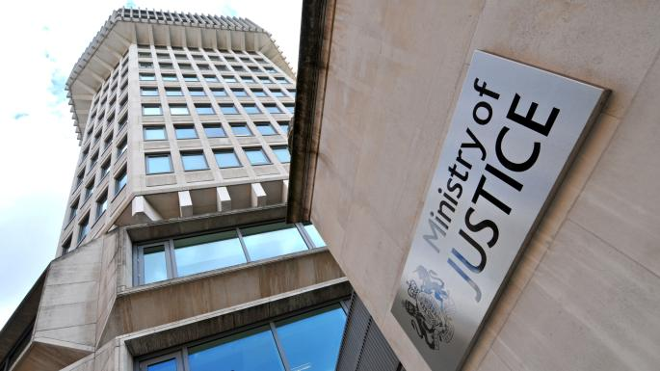
The Ministry of Justice said that research into the core sex offender treatment programme was not of sufficient qualityALAMY
Share
Save
A whistleblower who said that a sex offender treatment programme made some criminals more dangerous was treated unfairly by the Ministry of Justice, an employment judge has ruled.
Kathryn Hopkins’s research highlighted flaws in the programme in 2012 but it was not stopped until five years later. She has estimated that about 180 more crimes will have been committed by sex offenders who were treated in that time than had they not been.
Ms Hopkins had been asked to investigate the effect of the core sex offender treatment programme which had been used by the prison service since 1991. It was aimed at changing the thought processes of men in group sessions and behavioural therapy. Her first results suggested that prisoners on the programme were more likely to reoffend than those who were not.
In 2017 the treatment programme was scrapped and the Ministry of Justice released a report saying that 10 per cent of sex offenders who completed the core sex offender treatment programme (SOTP) committed at least one sexual offence in a follow-up period, compared with 8 per cent of those who had not been treated.
For offences involving explicit images of children the reoffending rate was 4.4 per cent for those who had done the programme, compared with 2.9 per cent in the comparison group.
Ms Hopkins accused the ministry of discrimination at an employment tribunal but lost her case because she had lodged her claim out of time.
Judge Tamara Lewis said in a ruling: “The final report confirmed what the claimant [Ms Hopkins] had been saying all along, ie that there was a higher rate of reoffending by prisoners who had undertaken the SOTP. We can understand the claimant’s frustration that it took five years to publish a report on such an important matter of public policy.”
The tribunal panel said that Ms Hopkins had been unfairly marked down in a performance review in 2014 because she had raised concerns about the SOTP. She was given a “must improve” rating which Judge Lewis said “caused her enormous distress” and prompted her to start a grievance procedure.
Ms Hopkins told the BBC that the ministry had “allowed people to continue attending the course” while knowing “it could be harmful”.
A ministry spokesman said: “Both internal and external experts who reviewed Ms Hopkins’s research judged that it was not of sufficient quality and that the methodology needed to be changed to remove the risk of bias and inaccurate results.”

