BY EMAIL
FAO Tom Kark QC

FPPR Review Team

c/o Department of Health and Social Care

21 September 2018

Dear Tom,

Wider application of the Fit and Proper Person Test

You will recall that I suggested on 31 August 2018 that any Fit and Proper Persons test should apply to the directors of central NHS bodies and the Department of Health and Social Care.

I contend that it is even more important to ensure that senior officials are Fit and Proper Persons, because they are in control and should be ultimately accountable.

Bad policy can kill many patients.

So can mismanagement and cover ups by central bodies and the Department of Health and Social Care.

You asked for two examples of DH failure which would support the need for FPP to apply to central bodies as well as provider organisations.

Example 1 Mid Staffs

In your closing submissions to the Mid Staffs Public Inquiry,
you made several criticisms of the Department of Health. For example, the relaxation of quality standards in order to drive forward a political imperative to establish Foundation Trusts:

“The inquiry may well conclude that the criteria for the Secretary of State's support, insofar as quality was concerned, were lowered over time as an inevitable consequence of the drive to achieve more foundation trusts across the country. The inquiry may conclude that in allowing those with only a fair rating for quality to go forward to Monitor and in allowing applications to proceed on the basis of plans to be compliant, and not putting in place any additional measures of quality, the Department of Health made it easier for a trust like Mid Staffs to slip through the net of the application process.”

Your closing submissions noted the difficulty with an approach which lacked due regard for whether providers were being given fair and achievable goals, which some might view as a form of bullying:

“ However, it may be apparent from the paragraphs above that there were de facto serious limitations to the extent to which anybody should have relied on the fact of the Secretary of State's support for an applicant to provide assurance that the organisation was providing safe and good quality care to its patients. Neither the SHA filter nor the Department of Health filter achieved that effect, and after the break I am going to turn to Monitor. It also reveals, we submit, the difficulties which arise when you try to separate finance from the quality of care which a trust is required to deliver.”

Your closing submissions noted that a number of senior officials, including from the Department of Health, hotly denied and dismissed the findings of the 2008 JCI report which found a top down culture of bullying:

“ Well, Sir Liam was sceptical about the use of the JCI report and as regards its claim about a blame culture, he described it as a wild-eyed attack on very flimsy evidence….

Indeed, in general, the Department witnesses did not accept or even recognise some of the criticisms contained in the American reports, and yet many of those criticisms of a top-down and bullying culture were described by witnesses to the inquiry”

You also commented on reputation management by the Department of Health, which seemed to take precedence over the need to protect the public and save lives. The following observation related to the Department’s reaction to the Healthcare Commission’s 2009 investigation report into MidStaffs:

“In a note written in March of 2008 at the beginning of the inquiry, for the Secretary of State and Minister of State for Health, two senior health civil servants wrote: "The very worst case scenario would involve 100 plus premature deaths over a three-year period but the HCC is anxious to stress this is not a given." What perhaps is of interest about this note is not the statistical assumption but what it reveals about the approach of the Department of Health and the perceived sensitivities to the political impact of such figures. The note seems to focus on the potential political implications of the report and not on the fundamental issue of an early discovery of what was going on at this trust. No urgent intervention was requested, nor did the Department consider that the issues raised required intervention.”

You will recall that Dr Heather Wood the lead investigator for this HCC report was later gagged by the CQC, which also disbanded the central investigation within which she worked, that helped to uncover the poor care and governance at MidStaffs. The central unit was disbanded despite evidence to the Inquiry and your conclusions about the lack of independence by the regional arm of the HCC:

“The issue is whether the regional arm of the HCC was sufficiently independent and applied sufficient scrutiny to identify the problems which there were. The short answer to that, we submit, on the evidence is that they were not and they did not.”

You noted evidence from Liam Donaldson about insufficient emphasis by the Department of Health on quality and patient safety:

“ Can I turn to the heading "Safety, quality and culture within the NHS". Sir Liam Donaldson stated that in his role as chief medical officer from 1998 to 2010, he sought constantly to drive quality up the agenda and lobbied for it to be taken on board as a central theme to healthcare improvement. However, his evidence described a picture of slow progress in putting quality centre stage within the priorities of the Department of Health.”

Example 2 Gosport

The panel investigation into the Gosport deaths disaster
concluded that the various bodies responsible for responding to the concerns from families, including the Department of Health, all failed to intervene effectively.

Page 321 of the Gosport panel investigation report:

“12.47 In the years following the re-emergence of serious concerns about the hospital, beginning in 1998, many NHS organisations had knowledge of at least part of the picture: Health Authorities, Primary Care Groups and Trusts, the regional office of the NHS Executive, the Commission for Healthcare Improvement and the Department of Health. Despite this, the documents make clear that no external organisation was able to intervene effectively to find out what had happened, to ensure that corrective action was taken, and to give the answers that the families and the public should have had many years ago.”

Correspondence from Liam Donaldson CMO in 2002 specifically acknowledged that there had been relevant disclosures from whistleblowers. He flagged a potential conflict of interest in that one of the trust managers responsible for Gosport at the time of these disclosures had become the Chief Executive of the local PCT:

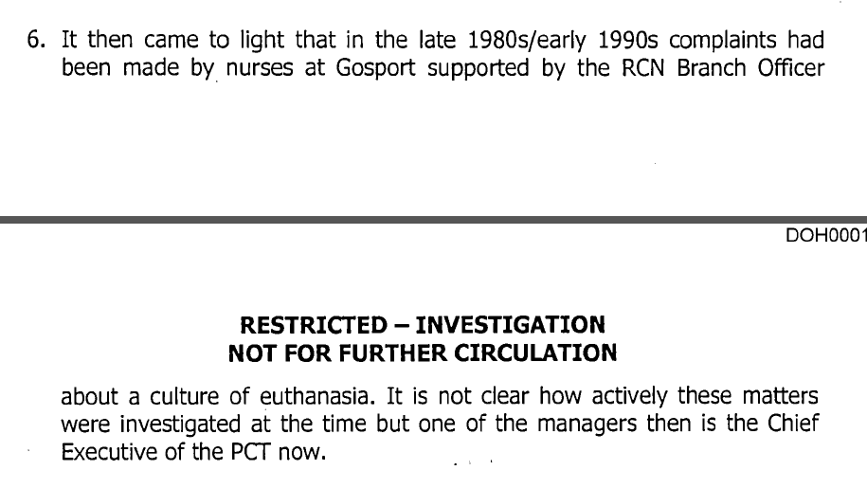

Despite all that has been revealed about the role of poor whistleblowing governance in patient safety disasters such as the unnatural Gosport deaths, the Department of Health failed to take real action to protect whistleblowers. It did not accept Robert Francis’ 2013 recommendation from Mid Staffs to criminalise whistleblower reprisal. In 2015 it went one step further and adopted a model of whistleblower ‘protection’ which involved leaving whistleblowers at the mercy of internal processes – the ineffective ‘Freedom To Speak Up’ project. An example of the serious failure of this model that has recently arisen is the decision by NHS Tayside’s whistleblowing champion to quit, after suffering stress and reporting that serious staff concerns were not taken seriously enough by the organisation.

Sir Liam also raised concerns about the robustness of CHI’s investigation methodology at Gosport. This would seem to be relevant material for consideration by the subsequent MidStaffs inquiries, as was other material from Gosport, and the Department of Health should have passed this data to the MidStaffs inquiries.

Instead, the Department of Health failed for ten years to publish a report on the Gosport deaths by Professor Baker, which it commissioned. The report was completed in 2003 and was not published until 2013. The Department rejected repeated FOI requests for disclosure of the report in the intervening years.

Despite the importance of the Gosport deaths, Department of Health officials denied that they were of national significance. Page 235 of the Gosport inquiry report:

“8.13 Colin Phillips, a DH official, said that there would be no public inquiry as the case was “old and about the actions of individuals” (PCO000128, p3). It was further pointed out that the deaths at Gosport War Memorial Hospital (‘the hospital’) did not, in the opinion of DH, “raise issues of national concern” (PCO000186). Nor would the Ministry of Justice or DH provide any funding for the inquests if they were to take place (PCO000128, p4).”

The Department of Health was also criticised by the Gosport inquiry for resisting disclosure of some its documents on Gosport until the last minute:

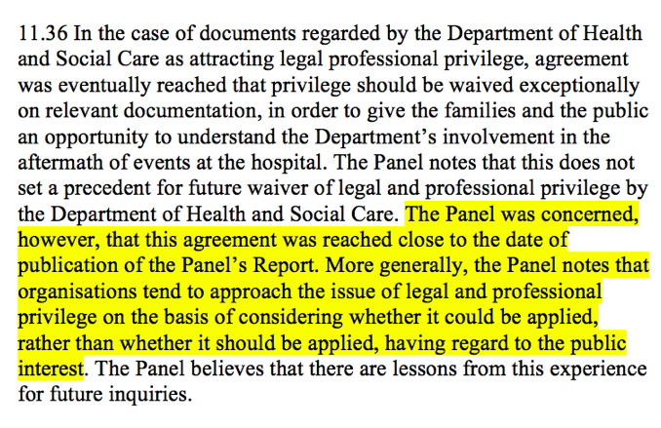

I think these two summarised examples demonstrate that are instances of ineffective leadership by the Department of Health, with very significant ramifications. These failures have more impact on patients than the behaviour of managers of local provider organisations.

The Department of Health sets the tone. As per an FOI disclosure which I sent you on 31 August 2018 (see email at 09.13), a controversial NHS manager received a job reference from a former Department of Health minister, and this reference was cited as part of the evidence considered on FPP issues.

It is not logical or safe for individuals at the Department of Health and Social Care to be immune from formal Fit and Proper Person tests.

You asked me for just two examples. I appreciate that the Department of Health and Social Care has asked you to work to a very tight schedule. But whether or not you are able to take the following information into account, I provide it because it is my view pertinent and important to the task of the FPPR review.

Example 3 CQC and whistleblowers

As I put to you at the evidence session on 31 August 2018, the fact that a review of FPPR has had to be commissioned is evidence of poor performance by the CQC, and part of the argument that the directors of Arms Length Bodies should be subject to an FPP test.

CQC’s handling of FPPR has featured both mismanagement and failures of candour, which appear deliberate. It protected itself from scrutiny by making its decisions about FPPR in private and giving little meaningful feedback to some referrers. In the case of Paula Vasco-Knight, CQC failed to be open at all abo

I contend that the CQC is hostile overall to whistleblowers. It copes poorly with challenge and dissent, and its natural reaction when challenged is to project blame.

It has dragged its feet endlessly on putting appropriate governance into place for whistleblowing by the staff of regulated bodies. Efforts to persuade it to do so are received poorly and resisted. In 2011 I had to suggest to the then Chair of CQC that the organisation ought to have an external whistleblowing policy. Latterly, it took two over years of correspondence and campaigning before CQC took the basic step of routinely tracking and publishing data about whistleblowing events.

Even now, CQC has still not devised any basic mechanism for tracking ET1 notifications from the Employment Tribunal about whistleblowers’ cases, concerns and reports of detriment. I copied you and Jane into correspondence with the CQC’s Chief Inspector of Social Care about this (see email 18 September 2018).

A subject access request last year revealed that without informing me, the CQC started handling me as a ‘frequent correspondent’ in 2012, when I was still disclosing serious patient safety issues such as deaths in custody and a patient’s complaint of Winterbourne View type institutional abuse and serious reprisal. In retrospect this explained why CQC started inexplicably ignoring my protected disclosures in 2012, despite having acknowledged prior to that my disclosures were valid and reliable. My reading is that CQC wished to stop hearing what I had to say because my additional disclosures in 2012 were a political inconvenience.

The fact that CQC started handling me as a ‘frequent correspondent’ in 2012 was revealed by a single email from 2015 which slipped through. All other correspondence about the decision in 2012 to handle me as a ‘frequent correspondent’ was withheld by CQC, with no indication to me that it had done so or any explanation of why the documents had been withheld.

The CEO of CQC has now admitted that a senior manager from CQC Complaints department was assigned in 2012 to oversee my correspondence, but he implausibly insists that CQC has disclosed all records and has no other records to disclose. This may of course imply that the records of the special handling in 2012 have been destroyed by CQC.

The same 2017 SAR disclosure by CQC revealed other matters such as planned, concerted online monitoring and another, later undisclosed ‘handling strategy’. (The phrase used by CQC’s Head of Legal Services, who was an important party in devising CQC’s approach).

I am very concerned that CQC has rejected some FPPR referrals because a proper investigation of the events in question would have led back to CQC’s own failures and improprieties in ignoring and helping to suppress whistleblowers.

I am concerned generally that CQC’s handling of FPPR referrals has been tainted by its hostile and defensive attitudes towards whistleblowers, and the fact that it has had secrets of its own to protect.

Moreover, CQC’s sub-committee, the Office of the National Guardian, has been implicated in inappropriate briefing. It warned Jeremy Hunt’s office about whistleblowers whom it had actually invited to a conference in their capacity as members of its advisory group, which implied some tokenism in engaging with whistleblowers. In the course of making misleading claims about the success of the Freedom To Speak Up project, it has also breached the UK Statistics Authority’s code and has delayed and obfuscated since being challenged. It has not published the original dataset that it should have published when making a misleading statistical claim, and has instead set about gathering new, reconciled data before publishing. Even then, the new dataset does not support the Office’s original claim.

Please accept examples 1, 2 and 3 as evidence in support of the fact that FPP tests need to be applied to central NHS bodies and the Department of Health and Social care.

Self evidently, any such mechanism would need to be independent of the Department of Health and Social Care and the government.

With best wishes,

Minh

Dr Minh Alexander

Cc Jane Russell

