NHS whistleblowing doubles but critics say watchdog lacks power
Lucy Bannerman
November 17 2018, 12:01am, The Times
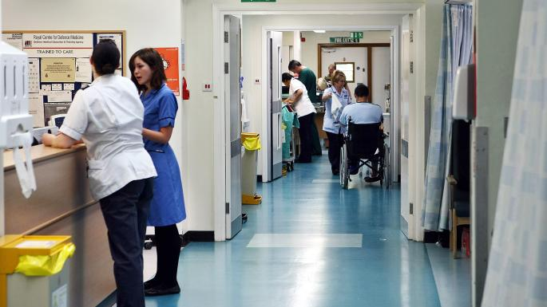
About 45 per cent of the complaints reported related to bullying and harassmentDAVID JONES/PA
Share
Save
More than 12,000 NHS cases have been referred to the national whistleblowing tsar in the past 18 months.
Henrietta Hughes, the national guardian for the health service, said that employees had reported twice as many concerns over health and safety to her network of 800 guardians at hospital and ambulance trusts throughout England, compared with last year.
About 45 per cent of the complaints related to bullying and harassment, while about a third involved concerns over patient safety. Nurses were the group most likely to report a concern.
Dr Hughes, a GP and NHS manager, said the rise in complaints should be seen as a sign of greater confidence among NHS employees to speak up and challenge senior management when they encountered bad practice.
However, her claims were dismissed as “codswallop” by Minh Alexander, a former whistleblower and safety campaigner, who said Dr Hughes’ office had no mechanism to differentiate the serious cases from “low level gripes”.
Professor Sir Brian Jarman, who specialises in health safety data at Imperial College London, also questioned the impact of the national guardian, adding: “As far as I know, the vast majority of NHS whistleblowers are fired, gagged and blacklisted.”
He called for a body independent of the health service that whistleblowers could report to. The National Guardian’s Office was set up in 2016, following the Stafford Hospital scandal, in which staff concerns were ignored and hundreds of patients died unnecessarily.
Responding to accusations her office lacks real power, Dr Hughes said: “We’ve got examples where trusts have actively suppressed speaking up, and it hasn’t really done them an awful lot of good in the long run. My experience is that trusts don’t want to find themselves in that position.”
Ms Alexander said: “Just because the numbers are increasing, does not mean that the role is effective. It’s codswallop. There has to be real accountability.”
In total, 12,075 cases were reported to guardians, with 2,600 new cases during the third quarter of this year, compared with 1,300 cases during the first quarter of last year.

Comments(1)
Ian Alexander
Comment by Dr Minh Alexander:
The National Guardian's Office and the Department of Health and Social Care's Freedom To Speak Up Project were created after the government rejected robust recommendations from the MidStaffs Public Inquiry to strengthen whistleblower protection. The Freedom To Speak Up project is cosmetic, misleads NHS staff into thinking that it is safe to speak up when protection remains very unreliable - especially from the National Guardian's Office - and it is very wasteful.
The National Guardian's Office costs £1million annually. It was originally intended to review whistleblowing cases which had been badly handled. However, the Office has devoted its energies to publicity and spin, and has completed only three reviews since establishment in April 2016. That is notwithstanding the resignation of the first National Guardian and her deputy before the Office was even opened.
There are too many serious flaws with the National Guardian's Office and the Freedom To Speak Up Project to enumerate, but a most revealing matter is the fact that the National Guardian asks Freedom To Speak Up Guardians to collect very superficial feedback data from NHS staff which does NOT include finding out whether staffs' concerns are addressed.
The National Guardian's Office has conjured up exclusion criteria that do not exist in its published guidance, in order to reject requests from whistleblowers to review their cases. For example, disclosed correspondence showed that a mass referral from 24 staff at troubled Brighton and Sussex University Hospitals NHS Trust was parked on the very strange purported basis that a case review by the National Guardian might impede improvement: "The purpose of a case review, whilst not aiming to be burdensome, could inhibit an organisation from making improvements".
It is possible of course to raise concerns without ill consequence in the NHS, but staff who raise the most challenging issues or persist when their concerns are not resolved face significant risk of reprisal. At present, the National Guardian encourages disclosures but does not fulfil her end of the bargain by ensuring that staff are protected when things go wrong. She in fact has no power to do so even if she was inclined. Some Freedom To Speak Up Guardians have informed me that they are bullied. The National Guardian is very quiet about that, but then she would be.
I urge all staff who are contemplating whistleblowing to read around and acquaint themselves as much as possible with the dangers and obstacles ahead of them. This is not to say they should not whistleblow, but they should do so based on knowledge of the real facts and not a mis-sold, rosy government promissory note.
What we really need is substantive reform of wholly unfit UK whistleblowing law, the Public Interest Disclosure Act. The Act bizarrely confers no protection, does not require investigation of whistleblowers' concerns and does not deter reprisal with any penalties for the individuals responsible. The government and the National Guardian resist law reform, which starkly shows the real level of protection available for UK whistleblowers.
Dr Minh Alexander, NHS whistleblower and former consultant psychiatrist

