BY EMAIL

BEIS Committee
Health and Social Care Committee
Public Accounts Committee
Public Administration and Constitutional Affairs Committee
Committee on Standards in Public Life
Joint Committee on Human Rights

29 September 2018

Dear Ms Reeves, Dr Wollaston, Ms Hillier, Mr Jenkin, CSPL Secretariat, Ms Harman,

UK government does not track whether whistleblowers’ concerns are addressed

I write to forward continuing evidence of the failure of current UK government policy on whistleblowing.

The NHS National Guardian’s Office and an underpinning network of internal Guardians within local NHS organisations, is held up by the UK government as a prototype.

The National Guardian’s Office acts as the secretariat for a pan-sector network on whistleblowing. It liaises with the financial sector and with other government agencies such as the MoD which also have internal whistleblowing ‘Champions’ and designated officers.

Neither local NHS Guardians nor the NHS National Guardian have statutory status nor powers. Neither does the National Guardian intend to seek a different remit.1

This sort of model is much opposed by whistleblowers and supporters, who know that it cannot effectively and reliably protect whistleblowers. A body of evidence continues to accumulate regarding this.

A key concern I wish to pass to you is the fact that the National Guardian’s Office collects limited staff feedback data, controlled and supplied by NHS trusts, and inexplicably neither collects nor publishes data on whether NHS staff’s concerns are addressed:

Another health check on the quality of the National Guardian's data

When questioned by the Health Service Journal, the Office stated ‘data was collected locally on how concerns were resolved’. I know from FOI data that this is only partially true. Some NHS trusts do not ask staff if their concerns have been addressed and others have admitted to collecting no staff feedback data at all.

The failure to check that whistleblowers’ concerns are addressed seems to wholly conflict with the primary function of the Office to ensure safe and effective whistleblowing governance.

However, it does complement current UK whistleblowing policy as expressed in law through the Public Interest Disclosure Act, which does not compel anyone to investigate whistleblowers’ concerns. This is a huge failure of public protection.

The National Guardian’s Office failure to collate data on whether whistleblowers’ concerns are addressed mirrors the conduct of the 2015 Freedom To Speak Up Review by Robert Francis for the Department of Health. The report of the Review discussed extensively the fractious employment aspects of whistleblowing, but it did not report at all on the grave nature of protected disclosures that had never been addressed.

It is sobering that even after the revelation in June of hundreds of unnatural deaths at Gosport following suppression of whistleblowers, the only dedicated UK government whistleblowing agency – the National Guardian’s Office - shows disinterest in whether whistleblowers’ concerns are addressed.

Whistleblowing governance at Gosport in brief

The Gosport Inquiry released an internal memo of October 2002 by Sir Liam Donaldson CMO of which showed that the Department of Health became aware whistleblowers had raised concerns at Gosport in ‘the late 1980s/early 1990s’.

A 2003 Department of Health report released by the Gosport Inquiry referred to ‘tardy’ management response to the whistleblowers’ concerns:

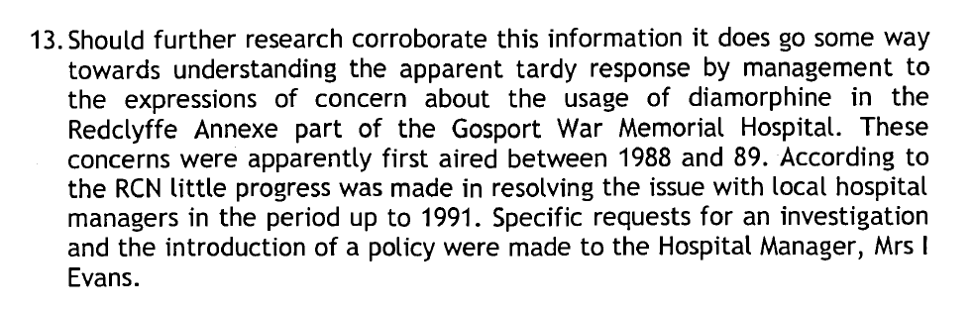
Disclosed records of a meeting on 17 December 1991 between the whistleblowers, managers, a Consultant Geriatrician and the doctor at the centre of concerns revealed minimisation, an emphasis on deference to authority, an instruction to confine further disclosures to the internal route and criticism of the whistleblowers.

The disaster that unfolded after Gosport whistleblowers repeatedly tried to raise the alarm but were ignored

Gosport Inquiry report page 27:

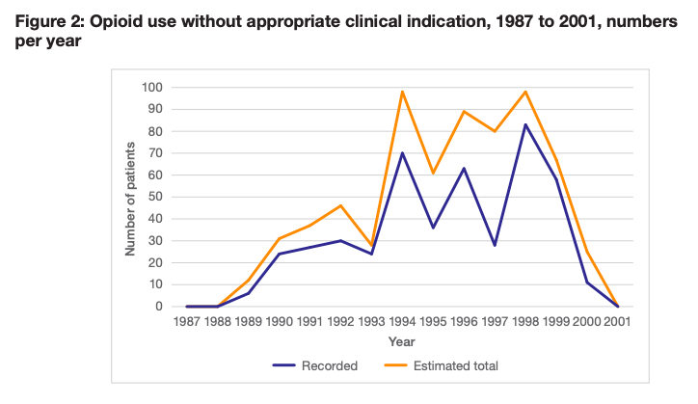

Gosport Inquiry report page 34:

Survival of those who were given continuous diamorphine without appropriate clinical indication: ‘59% were dead in two days or less.’

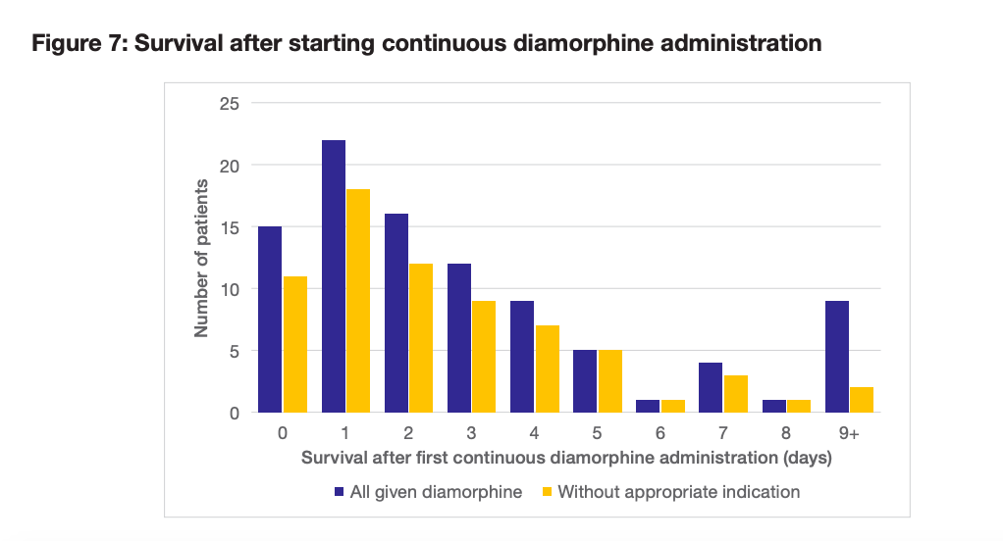

I hope that Parliament will recognise that it is time to end the last twenty years of fruitless whistleblowing litigation under PIDA in the Employment Tribunal, which drains the public purse but without protecting the public. Substantive reform of UK whistleblowing law is needed.

Replacing the Public Interest Disclosure Act

I also ask parliament to set aside ineffective, compromised models of internal Guardians and Champions, which are also wasteful and risky both to employees who act as ‘Guardians’ or 'Champions' and to inexperienced whistleblowers who disclose without understanding the limits of the model.

Yours sincerely,

Dr Minh Alexander

NHS whistleblower and former consultant psychiatrist, MinhAlexander.com

Cc

Ann Reeves
Julie Bailey
Clare Sardari
Martin Morton
Prof Brian Jarman
David Kaye UN Special Rapporteur on the Promotion and Protection of the Right to Freedom of Opinion and Expression, UCI
Bishop James Jones’ Office
Rob Behrens PHSO
Rosemary Agnew SPSO
Sir Amyas Morse NAO
David Isaac EHRC
Jennifer Benjamin DHSC
Chris Page DHSC
Daniel Malynn DHSC

1 Upon taking up post in October 2016 the National Guardian indicated in an interview to The Times that she did not envisage her lack of statutory powers would be a problem: “Some critics have said that her office can achieve little without formal investigatory powers, but she insisted that most people in the NHS wanted to improve and a lot could be done by helping them. “I’m really hoping to work in partnership as a supportive and developmental arm rather than something which is seen as punitive,” she said” On 18 January 2017 campaigners invited the National Guardian to seek powers and a stronger remit for protecting whistleblowers: “In brief, we recommend: - Creation of an independent body, that reports to parliament, with powers to investigate and remedy poor whistleblowing governance by public bodies We recognise that your office is not established in this way, but ask that you consider seeking changes to how your office operates, its powers and its budget, sufficient to deliver the above objectives. Your predecessor indicated that she intended to review progress after six months in post, and to consider any changes to the office to deliver more effective whistleblowing governance. Perhaps you would consider doing so, especially given that the Chief Investigator of the newly established Healthcare Safety Investigation Branch is seeking statutory independence and greater powers, to enhance investigatory functions and to compel NHS bodies to accept its recommendations.” On 16 February 2017, the National Guardian responded: “Whilst the National Guardian’s Office does not have powers overseen by parliament, its thinking and the recommendations it makes are independent from any other body or organisation. Naturally, whilst preserving our independence, it is important that we do not work in isolation so partnership working with other organisations within and around the NHS is vital – this is an approach we would take whether we held statutory powers of our own or not. Whilst we do not have statutory powers to investigate whistle blowing, we will review cases where NHS trusts have handled the concerns raised by their staff poorly. Our intention is to assess such cases against the principles of good practice set out in the Francis ‘Freedom to Speak Up’ Report. We intend to publish our findings and recommendations that arise from the cases we review, so that learning is shared across the system and speaking up culture can be improved. Amongst other activities we will also work closely with the Care Quality Commission to develop guidance on the freedom to speak up processes in trusts, so that this can be properly incorporated into the Well Led domain of their inspections. We are also forging links to the work of NHS Improvement to further help ensure that trusts make the necessary improvements we identify.”

