https://www.businessinsurance.com/article/00010101/NEWS06/912318805/DOJ-seeks-to-curtail-soaring-False-Claims-Act-cases

DOJ seeks to curtail soaring False Claims Act cases
REPRINTS
Judy Greenwald
1/29/2018 12:56:00 PM

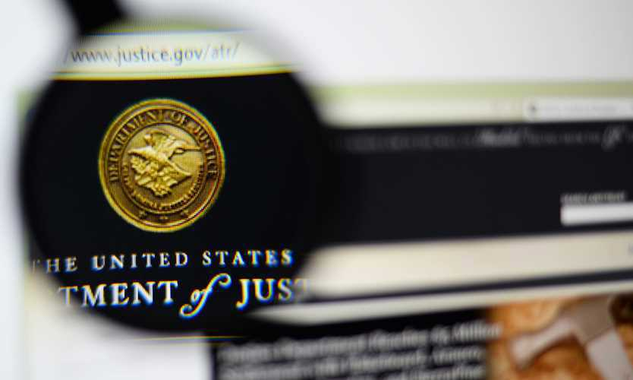
A U.S. Department of Justice memo, revealed last week, that guides its attorneys on when they should seek dismissal of False Claims Act whistleblower cases could lead to a decline in the soaring number of lawsuits filed, although its ultimate impact remains unclear, observers say.
Over the last 10 years, there have been record increases in qui tam, also known as whistleblower, cases filed under the False Claims Act, with annual totals approaching or exceeding 600 new matters, said Michael D. Granston, director of the Justice Department’s commercial litigation branch, fraud section, in a memo to department attorneys.
He said Justice Department attorneys have sparingly relied on a section of the act that permits them to seek dismissal of these cases, in large part because whistleblowers can still proceed with their litigation anyway.
But it adds, the section “remains an important tool to advance the government’s interests, preserve limited resources and avoid adverse precedent.”
The memo says the seven factors that should be taken into consideration in determining whether to seek these cases’ dismissal are:
- Curbing meritless qui tams
- Preventing “parasitic” or “opportunistic” qui tam actions
- Preventing interference with agency policies and programs
- Controlling litigation brought on behalf of the United States
- Safeguarding classified information and national security interests
- Preserving government resources
- Addressing egregious procedural errors
Gejaa T. Gobena, a partner with Hogan Lovells US L.L.P. in Washington and formerly deputy chief of the fraud section in the Justice Department’s criminal division, said over the past couple of years, as whistleblowers have been more willing to proceed with their cases, businesses have had to “spend a lot of resources” defending cases that are not meritorious.
A situation where the Justice Department, hopefully, more thoughtfully evaluates these cases may result in more of them being dismissed, said Mr. Gobena.
John C. Dodds, a partner with Morgan, Lewis & Bockius L.L.P. in Philadelphia, who is a former federal prosecutor, said the memo’s significance is the Department of Justice is “recognizing for the first time that it has to do something about the continuing uptick in the number of qi tam cases that are filed, other than what is being done until how, which is deciding whether to intervene or decline and, when it declines, letting it be up to the (whistleblower) entirely whether the case proceeds.”
Mr. Dodds said, “I think it’s, frankly, an overdue recognition” that the current system is not sufficient.
Mr. Dodds said the three factors that will determine whether the memo will have an impact are the extent to which the guidance is followed by the prosecutors who make the day-to-day decisions in these cases; the extent to which the memo affects the plaintiff attorneys who file these cases; and the reaction of federal judges, who “have been getting increasingly impatient with the amount of time it takes for the government to decide to intervene.”

