From: Tom Lloyd <***********************>
Subject: Re: The whistleblowing APPG & Donations to Whistleblowers UK (WBUK)
Date: 4 September 2018 at 17:31:34 BST
To: Minh Alexander <****************************>
Cc: ********************************************************************************************************************************************************************************************************************************************************************************************************************************************************************************************************************************************************************************************************

Dear Minh,

1. The page works for me on laptop and phone.
2. WhistleblowersUK will comply with its obligations to report donations.

Tom

Tom Lloyd QPM MA (Oxon)
Chairman, WhistleblowersUK

From: Minh Alexander <***********************>
Subject: The whistleblowing APPG & Donations to Whistleblowers UK (WBUK)
Date: 4 September 2018 at 13:05:57 BST
To: Tom Lloyd <****************************>
Cc: ******************************************************************************************************************************************************************************************************************************************************************************************************************************************

Thanks Tom

1. I am unable to access the ‘Donations’ page of WBUK's website.

When I click on the relevant part of your website homepage to select ‘Donations’ and ‘Commercial Donations’ from the menu, nothing happens.

When I try to access the page directly by searching the internet for ‘WBUK commercial donations’, it takes me to a page with an error message. Screenshot attached.

I wonder WBUK could look into whether there is any problem with the website.

2. Thank you for clarifying that there have been no disclosable donations.

Would WBUK be willing to disclose if it has received remuneration from law firms other than Constantine Cannon LLP, which litigate under US whistleblowing bounty hunting law, whether or not such payments are disclosable within the APPG rules?

Many thanks and best wishes,

Minh

Cc Members of the whistleblowing APPG:

Stephen Kerr MP APPG Chair
Baronness Kramer APPG Co-Chair
Norman Lamb MP APPG Vice-Chair
Annaliese Dodds MP APPG Vice-Chair
Andrew Mitchell MP APPG Vice-Chair

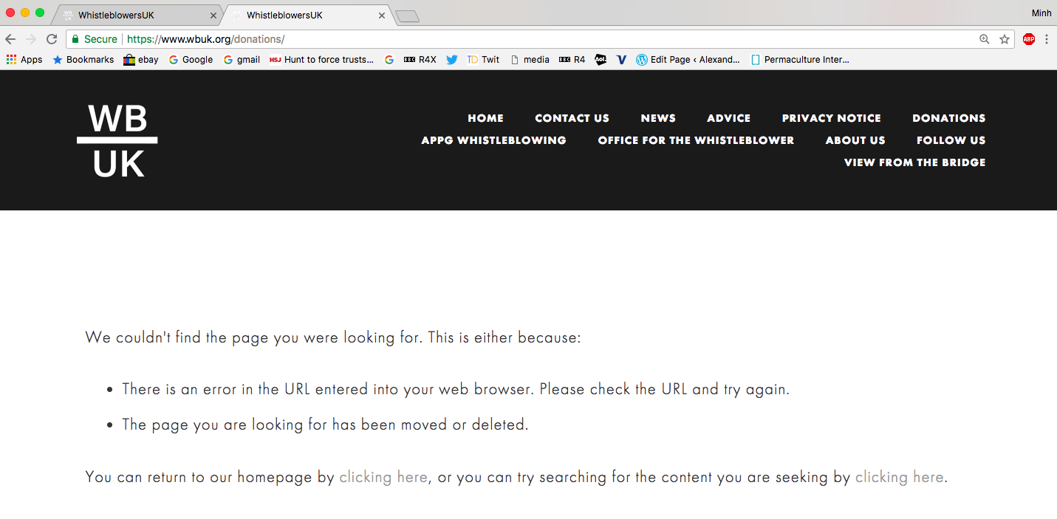

From: Tom Lloyd <**************************>
Subject: Re: The whistleblowing APPG & Donations to Whistleblowers UK (WBUK)
Date: 4 September 2018 at 12:50:24 BST
To: Minh Alexander <***************************>
Cc: ********************************************************************************************************************************************************************************************************************************************************************************************

Dear Minh,

All disclosable donations to WhistleblowersUK may be found on our website. Currently there are none.

Tom

Tom Lloyd QPM MA (Oxon)
Chairman, WhistleblowersUK

From: Minh Alexander <*************************>
Subject: The whistleblowing APPG & Donations to Whistleblowers UK (WBUK)
Date: 1 September 2018 at 13:51:34 BST
To: Tom Lloyd <*************************>
Cc: ***********************************************************************************************************************************************************************************************************************************************************************************************************************************

BY EMAIL

Tom Lloyd

Chair of WhistleblowersUK Company No 09347927, trading as Whistleblowers UK

1 September 2018

Dear Tom,

The whistleblowing APPG & Donations to Whistleblowers UK (WBUK)

A year ago you advised that WBUK preferred to keep the identities of its donors private, as per the correspondence copied below.

As WBUK now forms the secretariat of the new whistleblowing APPG, I wonder if it would be willing to reveal all relevant donors and donations that come within the APPG rules for declaration:

APPG Rules
“APPG secretariats and contact points
30. Each group must list in its Register entry any external organisation acting as its secretariat, if these services are of registrable value, and its designated secondary enquiry point for the public, if it has one. This enquiry point need not be within Parliament.
31. If an external donor funds another person or organisation to provide, for example, a secretariat or other administrative or support services, and the value exceeds the registrable threshold, that group must explain this in the Benefits section of its register entry.
32. Each group’s Chair and Registered Contact is responsible for ensuring if any person or organisation provides a secretariat or support services, that person or organisation is aware of and complies with the rules of the House. In particular, if a consultancy provides such services, and the value of those services exceeds the threshold for registration, it must be prepared to disclose information about its clients; if a charity or other not for profit organisation provides such services, it must be prepared to disclose information about its donors. The organisation providing the services must either publish this information online as a matter of routine or make it available within 28 days if any person or organisation asks them to do so. The information which must be made available is as follows:
a. If a consultancy provides a secretariat or support services whose value exceeds the threshold for registration: a list of any commercial organisations who were clients of the consultancy during the preceding twelve months; or, if providing the information on request, during the twelve months immediately before the month in which the request was made.
b. If a charity or other not-for-profit organisation provides a secretariat or support services whose value exceeds the threshold for registration: a list of any commercial organisation(s) from which the organisation has received donation(s) of more than £5,000 in total during the preceding twelve months; or, if providing the information on request, during the twelve months immediately before the month in which the request was made.”
https://publications.parliament.uk/pa/cm/cmallparty/rules/guide.html#_idTextAnchor021

The whistleblowing APPG has so far disclosed that the US law firm Constantine Cannon, which sues for whistleblowing bounty under US legislation, has paid WBUK to act as the whistleblowing APPG secretariat:
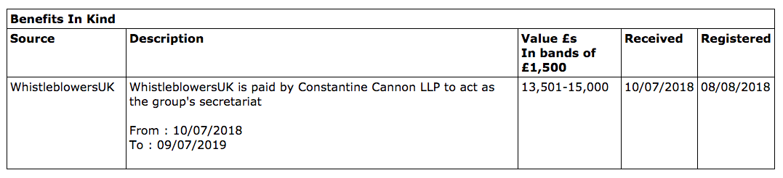

Specifically, I would additionally be interested to know if WBUK has received any renumeration from Philip and Cohen, another US law firm which sues for whistleblowing bounty, and which set up an office in the UK in 2016:

http://www.prnewswire.co.uk/news-releases/top-international-whistleblower-law-firm-phillips--cohen-opens-london-office-564097651.html

As you are probably already aware, Constantine Cannon and Philip and Cohen were co-counsel on the case of Andrew Patrick v Pure, in a whistleblowing bounty case using US law against a UK firm, which recouped monies (over $900K) for the US government from a UK firm:

https://www.phillipsandcohen.com/pure-collection-whistleblower-settlement/

I would also be grateful if WBUK could advise if it has received any remuneration from Bernstein, Shur, Sawyer & Nelson P.A who were also co-counsel on the Patrick case.

Many thanks and best wishes,

Minh

Dr Minh Alexander

Cc Members of the whistleblowing APPG:

Stephen Kerr MP APPG Chair
Baronness Kramer APPG Co-Chair
Norman Lamb MP APPG Vice-Chair
Annaliese Dodds MP APPG Vice-Chair
Andrew Mitchell MP APPG Vice-Chair

From: Tom Lloyd <***************************>
Subject: Re: Spending transparency and governance documents
Date: 29 September 2017 at 11:47:30 BST
To: Minh Alexander <******************************>

Dear Minh,

Thank you for pointing out that donations made through Givey are made public if the donor gives their name. Otherwise, as far as I can tell they are private. I was responding on the basis that we would not disclose the source of our donations as a matter of respecting the privacy of donors.

We do not have a governance document to share with you. As I said before we are a private company registered with Companies House.

Yours,

Tom

Tom Lloyd QPM MA (Oxon)
Chairman, WhistleblowersUK

