
Freedom of Information – Response Document – FOI 4737

Decision Notice:
Re: NHS whistle-blower employment support scheme

Please advise:

1. Has the trust been asked by NHS Improvement (NHSI) to take part in workshops about the NHS whistle-blower employment support scheme?

If so, please disclose correspondence between the trust and NHSI about this, and any information about the scheme, provided to the trust by NHSI.

Northumbria Healthcare NHS Foundation Trust received the below invite and agenda which was sent to every Trust in secondary and primary care.

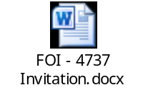

2. Has the trust been asked by NHSI to provide any managers to act as panellists for on the whistle-blower employment support scheme?

If so, please disclose the relevant correspondence between the trust and NHSI.

No. There has been no written invitation for panel members. Invitation to join the panel membership and associated training has been via newsletters and verbal invitation during various presentations and communication. Panel members do not represent the views of any trust but are expected to act impartially and independently during the panel meetings.

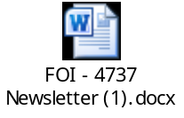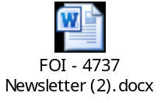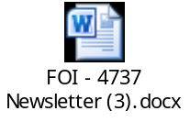

3. Has the trust been asked by NHSI to provide any of the following types of support to whistle-blowers on the pilot employment support scheme:

- Access to libraries
- Training opportunities
- shadowing
- guaranteed interviews for participants on the scheme
- Placements?

If so please disclose a copy of the correspondence from NHSI.

Yes, support has been requested through the workshops. Northumbria Healthcare NHS Foundation Trust has offered access to the Library.

4. Has the trust agreed to provide any of the following types of support to whistle-blowers on NHSI's pilot employment support scheme:

- Access to libraries
- Training opportunities
- shadowing
- guaranteed interviews for participants on the scheme
- Placements?

Please refer to response in Q3

5. Has the trust provided any of the above types of support to whistle-blowers on NHSI’s the pilot employment support scheme?

If so, please indicate how many whistle-blowers has the trust supported in this way.

Northumbria Healthcare NHS Foundation Trust does not have any participants on the scheme in our area at the moment.

Copyright Notice:

We would like to take this opportunity to remind you that information disclosed under the Freedom of Information Act is still protected by copyright laws. The disclosure does not give you ‘the applicant’ the right to breach the copyright of the copyright holder.

Any information provided is the property of Northumbria Healthcare NHS Foundation Trust and subject to Intellectual Property and Database Rights. Any commercial application or use of this information will be subject to the provisions of the Re-use of Public Sector Information Regulations 2005. This means that if you wish to re-use the information provided for commercial purposes for any reason you must ask us for permission to do so.

The information provided to you from Northumbria Healthcare NHS Trust should not be used to construct a database for direct marketing purposes and unsolicited emails infringing the copyright in the material provided or otherwise processed in contravention of the rights of the named individuals under the Data Protection Act unless you have our explicit permission separate to this FOI request.

To do so you will need to apply to:
Northumbria Healthcare NHS Foundation Trust
Northumbria House
Cobalt Business Park
Silver Fox Way, North Shields
NE27 0QJ

Or via e-mail at: foi@northumbria-healthcare.nhs.uk

How and When to complain:

Under section 50 of the Freedom of Information Act 2000 every applicant has a right to have any decision reviewed. In the first instance if you are dissatisfied with this response you must formally write to me providing details of your concerns. A review will only be accepted within 40 working days from disclosure of the information

If once we have conducted a review you are still dissatisfied with the response you have received from Northumbria Healthcare NHS Foundation Trust you have a right to complain to The Information Commissioners Office. This can be done by:

Post: Phone: E-mail:
First Contact Team 0303 123 1113 casework@ico.gsi.gov.uk
Information Commissioner's Office
Wycliffe House
Water Lane
Wilmslow
SK9 5AF

