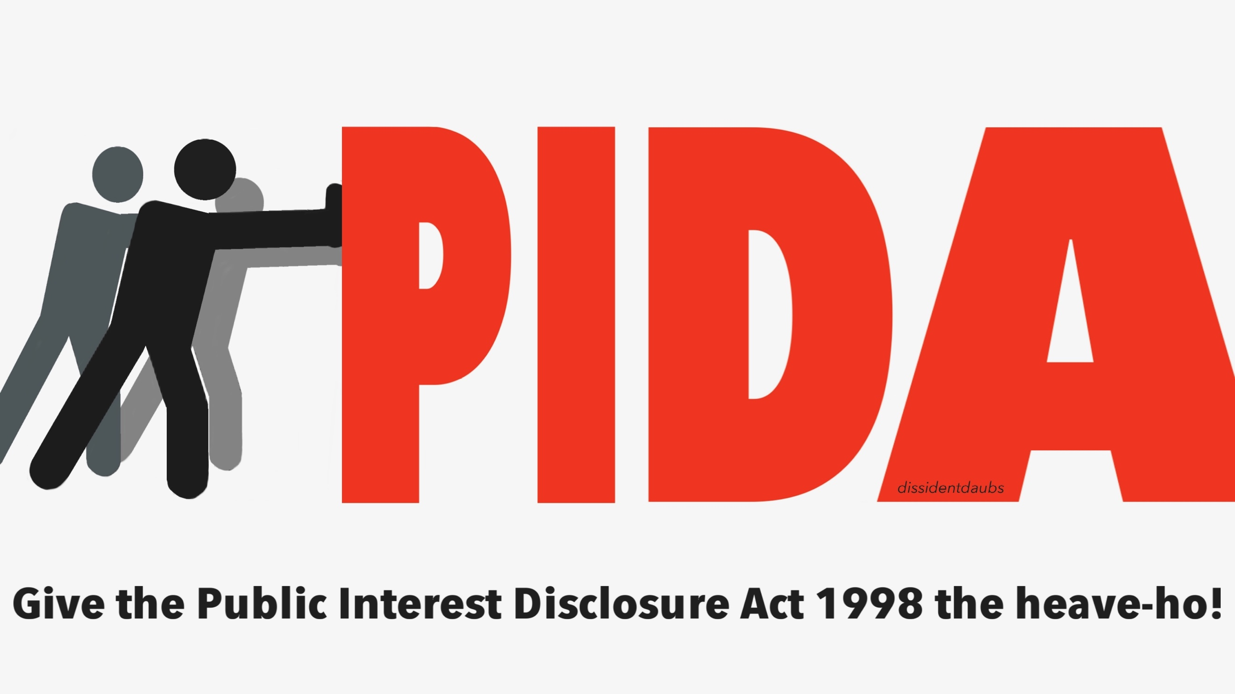

Forthcoming call for evidence from whistleblowers for a symposium on replacing the Public Interest Disclosure Act (PIDA)

A small scale symposium has been scheduled at CQC headquarters on 19th October 2018 to present expert legal evidence to key decision makers to make the case for legal reform, and generate in depth discussion.

The discussion will be focussed on wider issues with universality for all whistleblowers, to make the most of this precious and hard won opportunity.

For the background of how this event came about, see:

National Guardian, Spin Doctors and Dodging Reform of Whistleblowing Law

This will not be an event for presenting individual whistleblower journeys, but we would like to ensure that the event is informed by whistleblowers’ experiences. We will collate evidence from whistleblowers and publish this before the event.

We will invite whistleblowers to submit free text evidence as follows:

- Personal accounts of problems in using the Public Interest Disclosure Act

- Ideas on how they think the law should change.

We will shortly publish and circulate a form through which whistleblowers can submit evidence, after discussion at a meeting on 4 May 2018.

We would welcome evidence from UK whistleblowers in all sectors. Although the event is hosted by the NHS, the issues being discussed are relevant to all sectors, and evidence from other sectors is pertinent to how the NHS deals with these issues.

The aim is to make the case for law reform to a varied audience of key decision makers, some perhaps with little or no knowledge of PIDA. We will therefore ask whistleblowers who submit evidence to be very succinct. This will help maintain a sharp focus on failure of the law and keep the final report crisp and readable. The more succinct and clear the accounts are, the better the material will be for spreading the message.

To protect whistleblower who cannot currently be identified, and to ensure that the National Guardian will publish and help disseminate this material, all the whistleblower accounts will be anonymised and individuals and organisations will not be named and should not be identifiable.

As above, we stress that this is not a forum to present details of individual cases, but to effectively and concisely highlight legal issues that are common to all cases and of general interest to others.

The current event is only the start of a conversation. In due course, if whistleblowers and their supporters succeed in securing a formal review of UK whistleblowing law, such a review would be a very formal, public consultation into which individual whistleblowers could feed detailed case evidence.

Whistleblower facilitators

The event on 19th October 2018 will be facilitated by whistleblowers and we will in due course circulate details and invite expressions of interest from any whistleblowers interested in facilitating. Numbers will need to be limited and we will invite facilitators based on the best interests of all whistleblowers.

Please pass this leaflet to any whistleblowers whom you think may be interested in the project.

Thank you for your support.

Dr Minh Alexander and Clare Sardari NHS whistleblowers 26 April 2018

