National Guardian Advisory Working Group meeting November 2017 – meeting summary

The group was welcomed by the National Guardian, Dr Henrietta Hughes. Table discussions were facilitated on the following topics and the tables fed back to the room. All the outputs were shared with the group during the meeting.

The discussions were broad and to ensure that all views are captured in this meeting summary, word clouds have been created for each session from the points captured at the meeting. Next steps have been summarised with bullet points

Terms of Reference
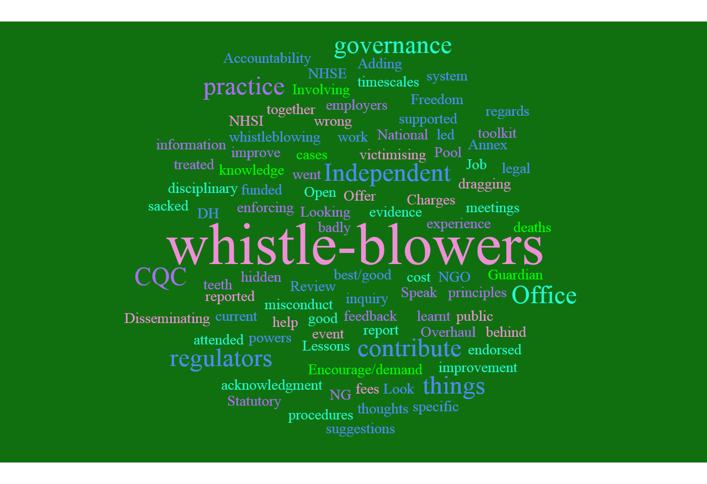

- Draft Terms of Reference document to be updated to include comments from the meeting, and circulated to members, including those who were unable to attend
- Further comments to be sent in by email by the end of January 2017
- Terms of Reference to be agreed at next meeting

Values and Expectations
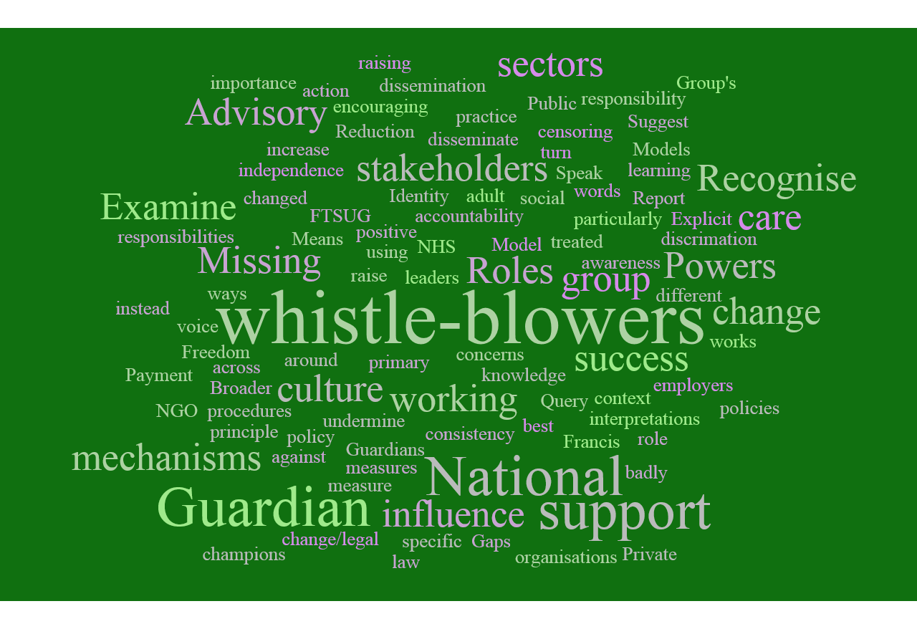
- Draft Values and expectations document to be amended to take in comments from meeting, and circulated to members, including those unable to attend this meeting.
- Any additional comments to be received by end of January 2017
- Final version to be agreed at next meeting

What matters to you
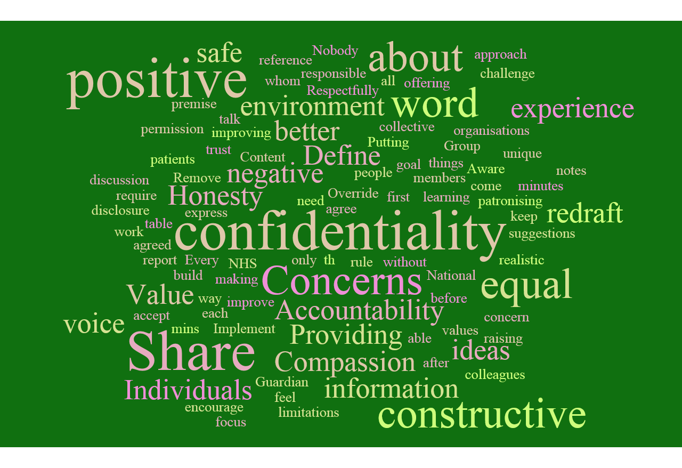
The main themes of discussion related to
- Working constructively and honestly
- Accountability of organisations
- Equal voice of participants
- Compassionate and respectful
- Request that providers are represented at the meeting
- A balance between providing a confidential environment where requested but generally operating in an open and transparent way

Suggestions for task and finish groups
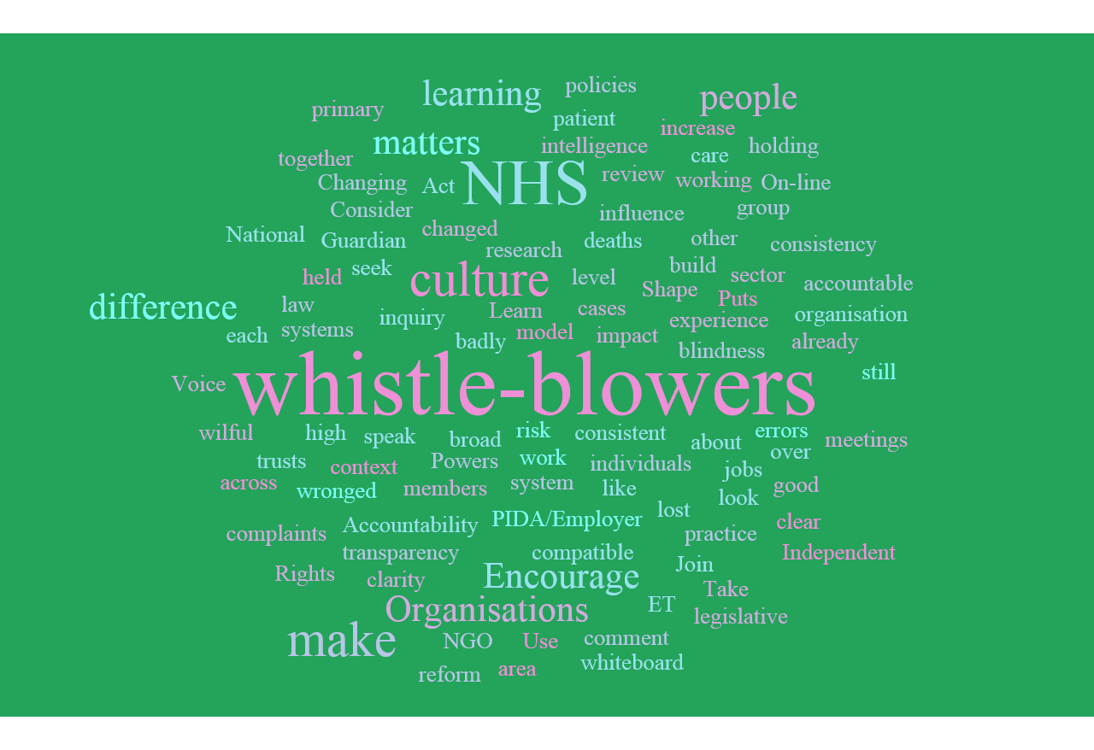
- Suggestion that a meeting is held, led by NHS workers who have spoken up
- Suggestion that Leadership training is developed that includes the voice of workers who have spoken up . Next meeting to have a general discussion on the scope of a task and finish group, aims, objectives and appropriate members with reporting times.

