2gether NHS Foundation Trust, National Staff Survey 2015 summarised results:

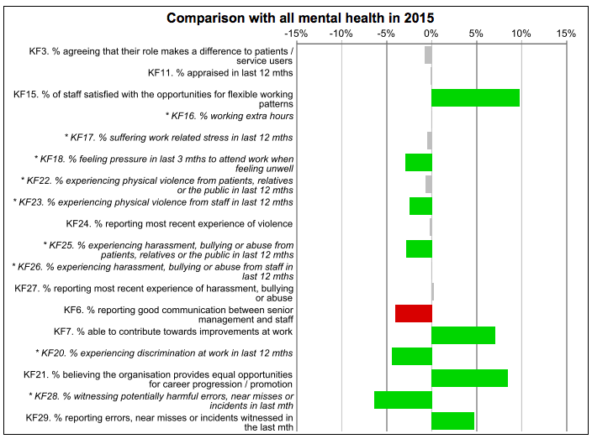

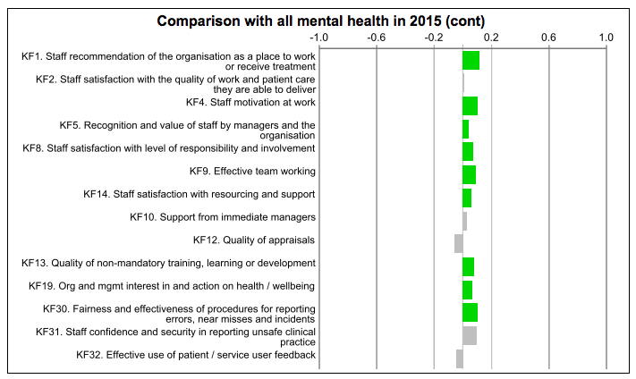

Northumberland Tyne and Wear NHS Foundation Trust, National Staff Survey 2015 summarised results:

